CONSOLIDATED FOCUS GROUP MEETINGS REPORT
Technical University of Varna (TUV)

June 2018

Contents

1. INTRODUCTION 3
2. OBJECTIVES AND METHODOLOGY 4
2.1. Objectives of the Focus Group Report 4
2.2. Methodology used 4
3. SITUATION IN BULGARIA 4
3.1. Technical University of Varna and maritime sector 4
3.2. Curriculums 6
4. PARTICIPANTS 6
4.1. Technical University of Varna 6
4.2. Keppel FELS Baltech Ltd (FELS) 7
4.3. MTG-Dolphin PLC (MTG) 7
4.4. German-Bulgarian Chamber of Commerce and Industry (AHK BG) 8
5. RESULTS FROM THE FOCUS GROUPS 8
5.1. Main topics discussed during the meetings 8
5.2. Main framework for pilot implementation of DET 10
5.3. Structure of the pilot implementation 11
5.4. Presentation and dissemination of the results 12
6. CONCLUSIONS AND RECOMMENDATIONS 13

INTRODUCTION

The present Focus Group Meetings Report (FGM Report) is based on the results of the regional working groups meetings organized by Technical University of Varna (TUV), with the Bulgarian partner companies within the framework of the European project titled DYNAMIC – Towards responsive engineering curricula through Europeanisation of dual higher education under ERASMUS + Programme, Key Action 2.
The meetings were held in the period March - May 2018 and hosted the Technical University – Varna. The partner companies and the abbreviation used in the report are as follows:
- Keppel FELS Baltech Ltd (FELS):
- MTG-Dolphin PLC (MTG)
- German-Bulgarian Chamber of Commerce and Industry (AHK BG)
The Report is organized as follows: Chapter 2 presents the objectives of the Report and the methodology used. Chapter 3 shortly describes facts in higher education at Technical University of Varna and the peculiarities in field of Naval Architecture and Marine Engineering. Special attention is given to the curriculum of specialty Naval Architecture and Marine Technology – the target specialty during the Project. Additionally, information for specialty Marine Engineering is given. Chapter 4 includes short presentation of the participants and makes an inventory of the topics discussed during the meetings. Chapter 5 summarizes the results from discussions, the issues raised during the meetings and the adopted decisions as well as the following steps in the implementation of the dual training in TU-Varna.

OBJECTIVES AND METHODOLOGY

Objectives of the Focus Group Report
The present Focus Group Report (FG Report) aims at:
- analysing the results of regional working groups meetings organized by TUV with the partner companies;
- review the curricula of the selected programmes;
- defined and analyse the required skills, according to the curriculum of each programme and the requirements of the partner companies;
- define the content and syllabus for the practical works (internships) and map the developed practical phases with ECTS.

Methodology used

The Report is based on the results of the focus group meetings.
Focus groups (FG) was organized in Bulgaria (at TUV), involving representatives of the Technical University of Varna and partner companies from Bulgaria. The information about the meetings and the participants is given in Table 1.
Table 1. Focus Group Meeting and participants
FG Meeting | Date | Partners | Participants
1-st FGM | 21.03.2018 | TUV; FELS; MTG; AHK BG | 11
2-nd FGM | 18.04.2018 | TUV; FELS; MTG; | 8
3-rd FGM | 16.05.2018 | TUV; FELS; MTG; AHK BG | 10

Representatives off all participants were involved in the discussions in order to collect the significant data regarding the main objectives of the focus groups. Data were collected by using session data form.

SITUATION IN BULGARIA

Technical University of Varna and maritime sector
The Technical University of Varna (TUV) was founded in 1962 by a Decree of the Council of Ministers of the People’s Republic of Bulgaria and Act of the National Assembly. The purpose of its establishment was to ensure conditions for education of engineering staff for the shipbuilding, transport, machine building, electric power engineering and communications.
Initially, the university incorporated three faculties: Mechanical Engineering, Electrical Engineering and Shipbuilding Faculty. The first admission of students was for the 1963/64 academic year. The specialties Shipbuilding (Naval Architecture and Marine Technology today) and Marine Engineering are from the very founding of the university. The mission of the university is:
- development of the intellectual potential of young people;
- ensure high quality education;
- support the processes of sustainable development;
- contribute to research and implementation of new ideas
Today structure of faculties and corresponding departments of TUV is presented in Table 2.

Table 2. Structure of Technical University of Varna
Faculty of Manufacturing Engineering and Technologies | Faculty of Shipbuilding | Faculty of Electrical Engineering | Faculty of Computer Sciences and Automation
Technology of Machine Tools and Manufacturing | Naval Architecture and Marine Engineering | Electric Power Engineering | Computer Science and Engineering
Materials Science and Technology | Navigation, Transport Management and Waterways Preservation | Electric Power Supply and Electrical Equipment | Software and Internet Technologies
Transport Equipment and Technologies | Thermal Engineering | Electrical Engineering and Electro technologies | Communication Engineering and Technologies
Technical Mechanics | Ecology and Environmental Protection | Theory of Electrical Engineering and Measurement | Automation
Industrial Design | Plant Production | Social and Legal Sciences | Electronic Equipment and Microelectronics
Industrial Management |  | Physical Education and Sports

The main fields of Bulgarian maritime sector considering the turnover for 2015 are shown in Figure 1. The maritime industry is concentrated in Varna region (Figure 2). These circumstances were at the core of the choice of the specialty Shipbuilding for pilot implementation of dual training in higher education in Bulgaria. This is in full agreement with the goal of the project i.e. “.. to address the need for more flexible routes for acquiring current industry-related skills necessary to boost and sustain innovation in the sectors identified by the national strategies of Smart Specialization and regional innovation in the new member states…”
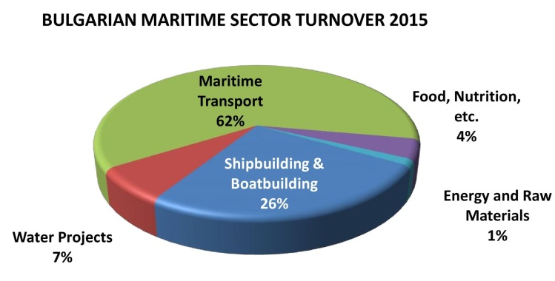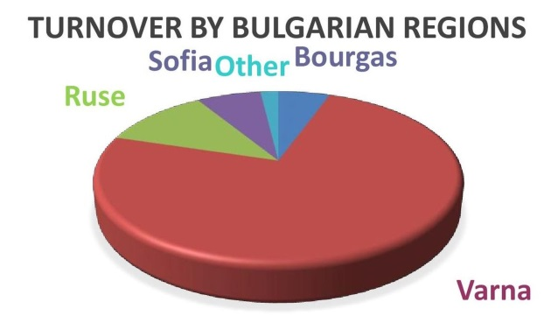
Figure 1. Bulgarian maritime sector turnover 2015 Figure 2. Regions of maritime industry¹

Curriculums
The regional meetings considered the curriculums for possible implementation of dual education training. There are two different curricula for the specialty of Naval Architecture and Marine Technology. The old one is applicable for the last year students in academic year 2018/2019. The new one is valid for students who will be 3rd years study.
Taking into account the planed implementation in the project i.e. from October 2018 the suitable target group are the students from 3rd Year in Academic Year 2018/2019. The peculiarities of the curriculum are presented in Table 3

Table 3. Main peculiarities of the curriculum of Naval Architecture and Marine Technology
Semester | No Special/Total subject | Academic hours | Self-study hours | Total hours | ECTS
1 | 2/5 | 195 | 605 | 800 | 30
2 | 3/10 | 330 | 525 | 855 | 30
3 | 2/8 | 285 | 570 | 855 | 31
4 | 2/7 | 300 | 585 | 885 | 32
5 | 5/7 | 255 | 615 | 870 | 31
6 | 6/8 | 315 | 540 | 855 | 30
7 | 6/7 | 330 | 525 | 855 | 31
8 | 4/5 | 240 | 375 | 615 | 22
TOTAL | 30/57 | 2250 | 4340 | 6590 | 237

The study in the Bachelor course finishes with the elaboration of a Diploma thesis or State Exam. Additionally to the shown subjects there are English Language course in semesters 2 to 8.

PARTICIPANTS

Technical University of Varna
Participants in the DYNAMIC project from TU-Varna are lecturers from the Naval Architecture and Marine Engineering Department. The work on the project is very well supported by the Vice Rector on Education and Vice Rector on Research. The both of Vice Rectors participated the first regional meeting (Figure 3).
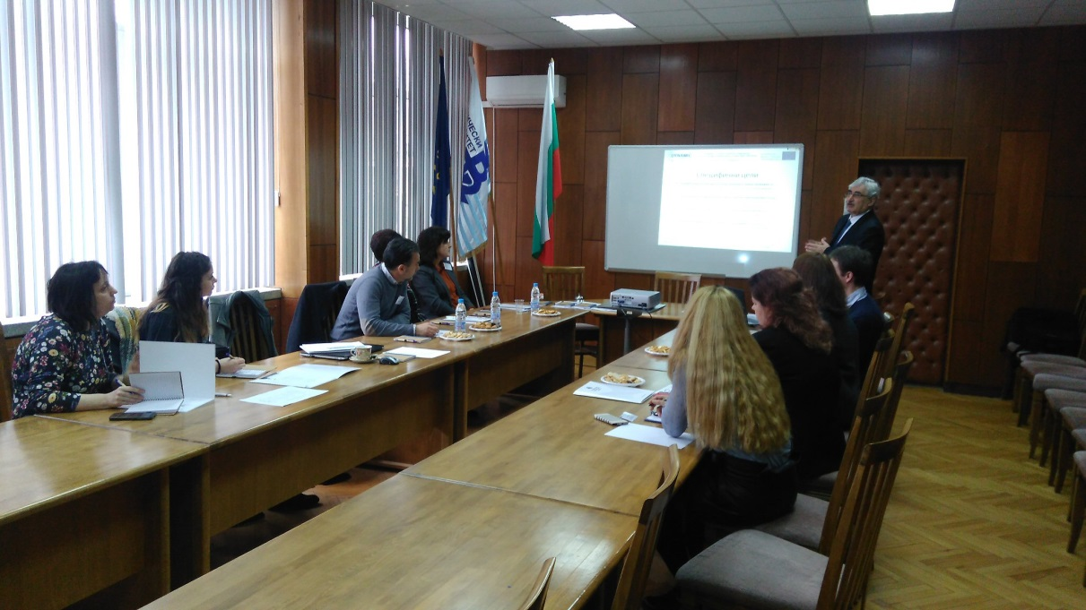
Figure 3.First regional meeting - 21.03.2018

Keppel FELS Baltech Ltd (FELS)

The company is established in Varna, July.1994 and it is the 1st European subsidiary of Keppel FELS – Singapore, part of Keppel Offshore & Marine – Singapore. The main activities are basic ship design and detailed engineering and FEM (Finite Element Modelling) of mobile offshore drilling units accommodation platforms, multi-purpose support vessels and offshore supply vessels.
The company has a good collaboration with Technical University - Varna which is expressed in:
- Participation and Leading the Council of business managers at Naval Architecture and Marine Technology specialty;
- Identifying talents from 3rd – 4th year of their engineering study at TU-Varna;
- Tapping and developing talent pool with best graduates from TU-Varna;
- Over 90% of the designers are graduates from the TU-Varna;
- Establishment of TU-Varna Design Lab – KFB Remote Engineering Office, since 01.2012
Involvement of Keppel FELS Baltech Ltd is in the following WP:
- WP2: finalization of the cooperative engineering curricula by stipulating the content of the practical phases for the pilot programs.
- WP3: development of a toolkit to facilitate and support the communication between the key stakeholders involved in the delivery of higher education programs
- WP4: participate in the training workshops for in-company trainers overall pilot implementation of DET program with ECTS coordination with TUV the pilot implementation.

MTG-Dolphin PLC (MTG)
MTG Dolphin is one of leading shipyards in Black Sea/ Mediterranean Sea region. The Shipyard is located at the northern shore of Varna Lake, right in the middle between Varna East and Varna West port, with unrestricted access to the Black Sea. The main facts connected with the big experience in the shipyard are as follows:
- 25 years of experience in repairs of vessels of up to 60’000 tDW.
- More than 10 years of building of highly technological and complex vessels of up to 16’000 tDW.
- More than 700 professionals in the shipyard.
MTG Dolphin is involved in the following WP and tasks:
- WP2: finalization of the cooperative engineering curricula by stipulating the content of the practical phases for the pilot program.
- WP3: in training how to use the toolkit for communication between the key stakeholders involved in the delivery of cooperative higher education program.
- WP4: participation to training workshops for in-company trainers
- WP5: In the overall pilot implementation of dual engineering practice-integrated study program with ECTS credits in Bulgaria

German-Bulgarian Chamber of Commerce and Industry (AHK BG)
The mission of AHK BG is:
- to foster economic relations between Bulgaria and Germany
- to create a platform for contacts, partnerships and exchanges between German and Bulgarian companies
- to consult and support its members in respective business fields
- new opportunities for successful business
- to provide a wide range of services; to meet the expectations of its customers
Involvement of AHK is in WP4 as a leader - responsible (with AHK Romania and CCE) to develop and conduct the trainings for enterprise mentors involved in dual higher education.

RESULTS FROM THE FOCUS GROUPS

Main topics discussed during the meetings
The main topics during the 1-st FGM (held on 21.03.2018 -Figure 4 ) were as follows:
- Current peculiarities related to the practical training of students; educational programs for marine specialties and syllabus, etc.
- Specifics in practical training, programs
- Possibilities and various ideas and opportunities for setting the foundations of the dual education practices and training.
- Ideas and requirements for partners’ co-operation within the project. How to deal with the challenge to set-up “dual education” in the best way?
- Identification of more specific issues/problems/tasks for next regional meeting in April at TUV.
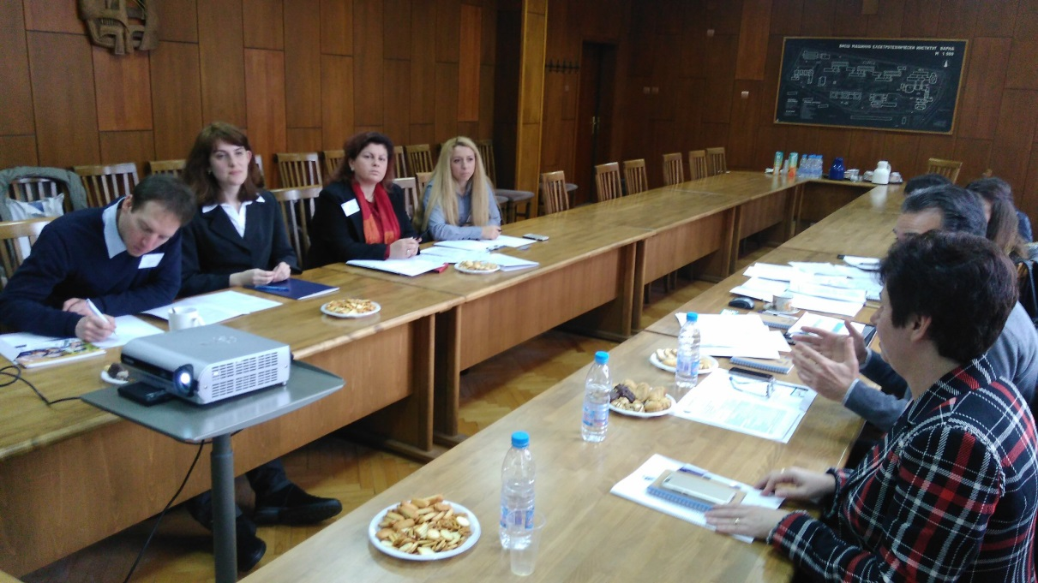
Figure 4. Working moment from 1-st FGM
The 2-nd FGM was held on 18.04.2018 ( Figure 5) and the following topics were considered:
- Information about the models for Dual education training (DET) in EU
- Discussion about the DYNAMIC guidelines for pilot introduction of practice-integrated dual curricula
- Curricula of NAMT and ME specialties - presentation and discussion of all specific features, in agreement with the corresponding legislation in Bulgaria
- Ideas and possibilities for implementation of DE, requirements to partners
- The most efficient schedule for practical education for the students from specialities “NAMT” and “ME” during the summer and winter semester and the summer vacation
- Schedule for practice-integrated training

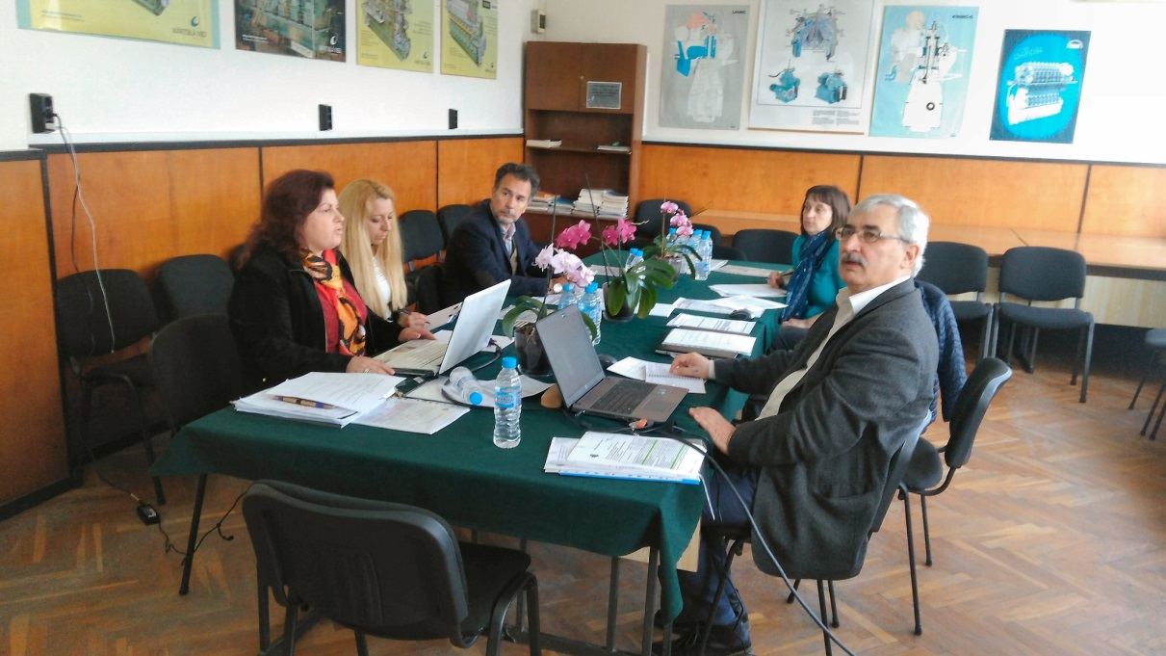
Figure 5. Moment from 2-nd FGM

The main topics during 3-rd FGM (16.05.2018 Figure 6 ) were as follows:
- Specification of the next steps regarding the implementation of dual education training. Personal information for students involved in dual education training and its pilot implementation
- Scope and presentation for Transnational Meeting in Pula. Outcomes of all 3 national focus group meetings in Bulgaria
- Discussions of the proposed diary template and contract template
- Questions and uncertainties to be placed in Pula

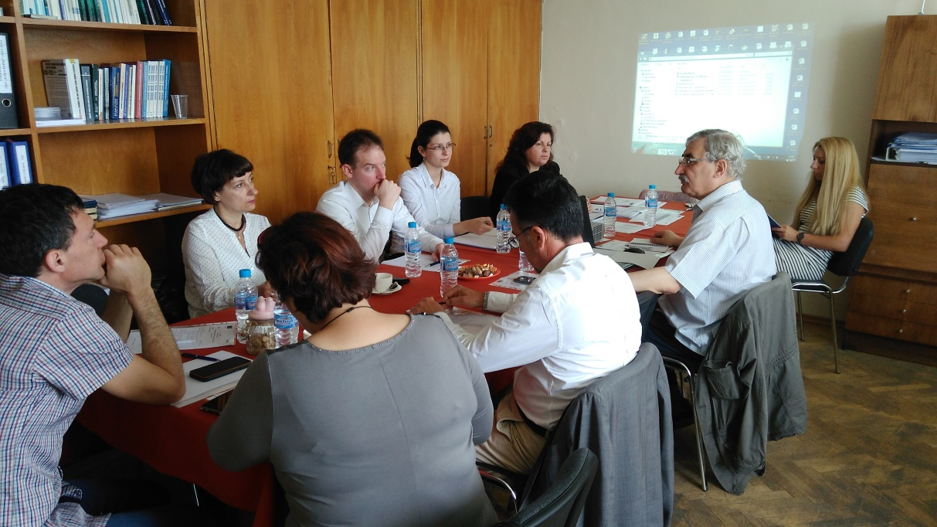
Figure 6. Working moment from 3-rd FGM

Main framework for pilot implementation of DET
During the discussions at the 3 meetings, there were outlined the principles of internal (belong to the Technical University Rules) and national legislation that should be taken into account. These rules dictate the choice of the structure of pilot implementation of dual education training. There were also principles mutually agreed with business partners.
The following rules should be taken into account:
- Any adaptation made to the curricula and in the contents of the syllabus, for various subjects, under consideration for dual education, must be approved by the responsible institutions. The procedure starts with a proposal of Department Council, acceptance by the Faculty Council and finally approval by University Council;
- According to the Higher Education Law, the student has to complete his/her training on the curriculum on which he / she started. This means, that in the frame of the project it’s not possible to change the curriculum and to provide a pilot implementation;
- It was agreed that could be useful for the students who are conducting the dual training, the diploma work at last year of study to be related to the activity of the corresponding company. At the same time, there is a rule that a Diploma thesis can develop students with a certain minimum grades. This should be additionally clarified;
- Taking into account the main activities of business partners and the essence of the curriculum of specialty Marine Engineering, the pilot implementation of the dual training is not suitable for the students from this specialty for the entire course of their education. Only some subjects are considered for DET
- In the enterprises included in the project an appropriate crossing regime has been established. This issue needs to be further organized in the light of the GDPR (General Data Protection Regulation) in force on 25 May. The participants in the project (Technical University of Varna, MTG Dolphin and Keppel FELS Baltech) will act according to accepted own procedure;
- The all documents and corresponding agreements between the Technical University of Varna, Business partner and Student will be agreed between the parties and will take into account all local rules and regulations.

Structure of the pilot implementation
There are a number of circumstances that facilitate the organization of dual training in Naval Architecture and Marine Technology specialty:
- The subject “Specialized practice” consists of 60 academic hours (2 ECTS), that are planned to be held during the summer vacation after the 6th semester.
- There are other subjects like “Marine Piping Systems, Electrical Equipment of Ships and Marine Structures, Technical Safety, Structural Mechanics of Ships and Marine Structures, Welding of Marine Structures, Strength and Structure of Ships that include more than 500 self-study hours;
The considered and accepted structure of dual training is organized in two phases: During semesters in TUV and in partner company – in summer vacation after 6th semester.
- Phase in TUV
- Organization of 3 Workshops. These workshops will be held at the Technical University and in each of the two partner companies. The goal of the first Workshop is to promote the conditions among the students. The next Workshops will be in the partner companies where the conditions and requirements of the business partner will be presented.
- Practical tasks during exercises given by the companies. The syllabus on some disciplines to be updated taking into account specific practical tasks posed by businesses.
- Phase during summer vacation
- Special internship after 6th semester to be followed by 3 month practice in the both of companies;
- The practice starts with the student's application and after approval by the company
- The practice of about 160 hours per month will be paid according to the company conditions;
- The conditions of the practice and the obligations of the parties - student, the company and TUV will be described in the corresponding agreement.
- Special training logbooks will be elaborated for the needs of pilot implementation

Presentation and dissemination of the results
In the period of March to May the work on the DYNAMIC project and some of the obtained results were presented to a wider audience.
After the 1st FGM Mr. M. Erhard from AHL BG gave a lecture (Figure 7) to students of maritime specialties at TUV. He discussed in details what it means dual education, its importance, positive aspects and outcomes. Students were eager to know more about the dual education systems, there were many questions regarding its provisional organisation and start-up, changes and new moments in curricula and syllabus, evaluation criteria and the enrolment procedures.

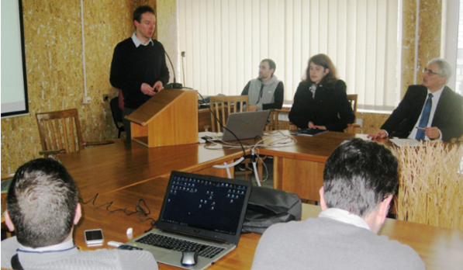
Figure 7. Presentation of. M. Erhard from AHK BG

The main results from the Focus Group Meetings were presented by Petar Georgiev (Figure 8) during the day Conference on 29.05.2018 in hotel “Cherno More” dedicated to European Maritime Day – 20 May and “50 years of first class naval architects and marine engineers graduated of TU-Varna” . The audience of the forum consisted of former and current students and professors in the Naval Architecture and Marine Technology and Marine Engineering specialties (Figure 9)

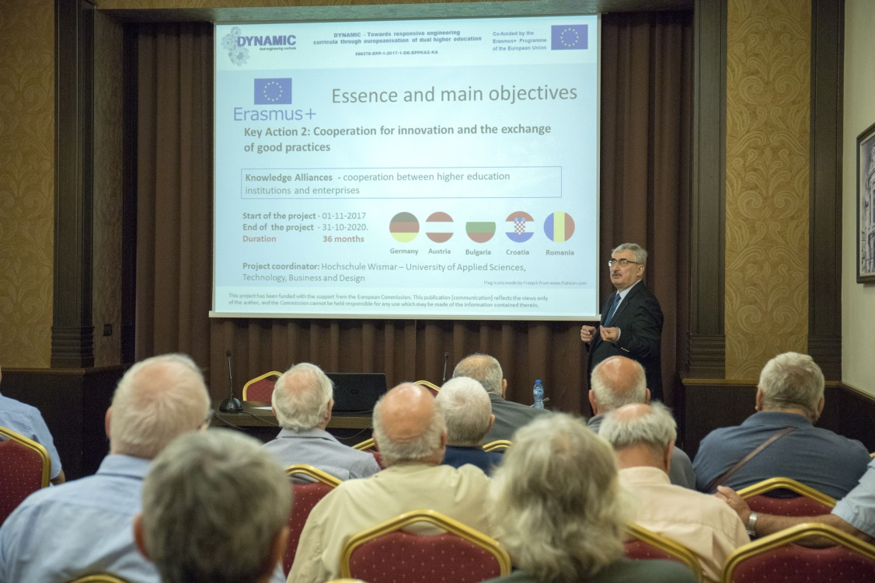
Figure 8. Presentation of Petar Georgiev, from TUV

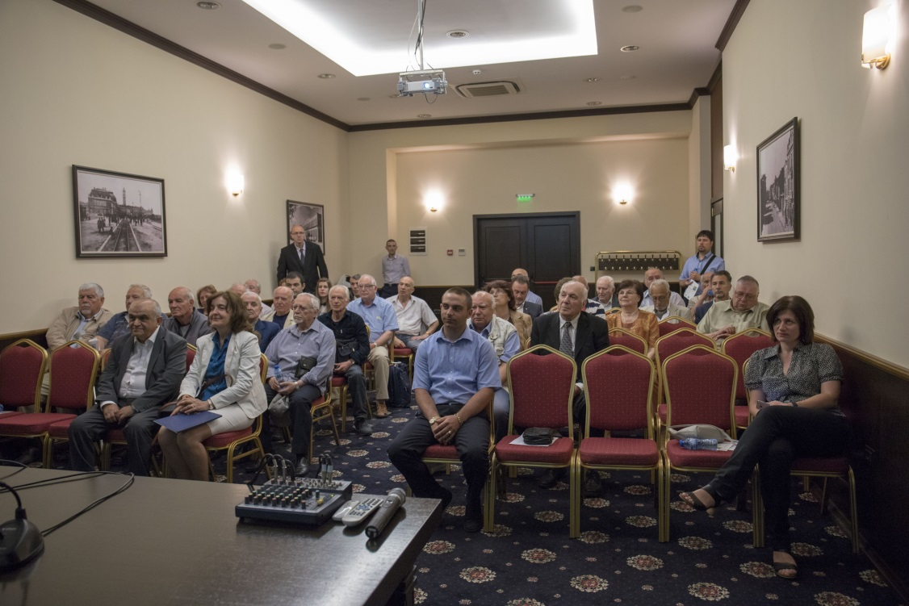

Figure 9. Audience of the Day Conference

CONCLUSIONS AND RECOMMENDATIONS

According to task 2.2 from WP2 TUV had to organize 3 regional meetings to discuss all aspects related to the pilot implementation of dual practice-integrated training for students from the Naval Architecture and Marine Technology specialty of Technical University of Varna.
In the period from March to May, 3 meetings in TUV were held. The following results were achieved:
- A structure for pilot implementation of dual practice-integrated training in specialty of Naval Architecture and Marine Technology of TUV has been adopted, which takes into account existing national and institutional legislation and existing curricula;
- Pilot implementation of dual learning will be based on a voluntary choice by the students of the 3-year course for the 2018/2019 academic year after approval by the business partners;
- The main part of the training will be provided during summer vacation and will consist of about 160 hours per month paid according to the company conditions.
- All the necessary documentation - contracts, logbooks, reports etc. will be developed taking into account local conditions, based on good practices in partner countries involved in the project.
- At the moment there are not many possibilities to provide practice-integrated dual learning for students of Marine Engineering specialty for the entire course of their education. Their education is more focused on the work of a ship's engineer on board of the ship. However, students in the specialty of “Marine Engineering” in their 4th year of education will be accepted by MTG Dolphin for practical training on “Repair of marine machinery”.
- Students in the specialty of “Marine Engineering” in their 1st and/or 2nd year of education will be considered to undergo for the second part of their practical training on “Metal turning” and/or “Metal fitting” at MTG Dolphin.
- The syllabus for students in the newly accepted specialty - “Design of marine plants and systems” is extremely appropriate for dual education. The possibilities for implementation of dual practice-integrated training for this specialty will be discussed after finishing of the enrolment procedure. It is worthwhile to consider extending the activities after project completion and looking for opportunities in this direction.

ACKNOWLEDGEMENT

This Focus Group Report was written by:

Petar Georgiev
Galina Ilieva

“The European Commission support for the production of this publication does not constitute endorsement of the contents which reflects the views only of the authors, and the Commission cannot be held responsible for any use which may be made of the information contained therein.”

From internal Report of Marine Cluster Bulgaria, 2017

