FOCUS GROUP REPORT
ROMANIA, BULGARIA, CROATIA

September 2018

CONTENTS:

1 INTRODUCTION 3
2 OBJECTIVES AND METHODOLOGY 4
2.1 Objectives of the Focus Group Report 4
2.2 Methodology used 4
3 PRESENT SITUATION 4
3.1 Situation in ROMANIA 4
3.2 Situation in BULGARIA 4
3.2.1 Technical University of Varna and maritime sector 4
3.2.2 Curriculums 5
3.3 Situation in CROATIA 6
4 PARTICIPANTS 6
4.1 Participants in ROMANIA 6
4.2 Participants in BULGARIA 7
4.2.1 Technical University of Varna 7
4.2.2 Keppel FELS Baltech Ltd (FELS) 7
4.2.3 MTG-Dolphin PLC (MTG) 8
4.2.4 German-Bulgarian Chamber of Commerce and Industry (AHK BG) 8
5 RESULTS FROM THE FOCUS GROUPS 8
5.1 Results from the focus groups in Romania 8
5.1.1 Overview 8
5.1.2 Analysis 9
5.2 Results from the focus groups in BULGARIA 11
5.2.1 Main topics discussed during the meetings 11
5.2.2 Main framework for pilot implementation of DET 13
5.2.3 Structure of the pilot implementation 14
5.2.4 Presentation and dissemination of the results 15
5.3 Results from the focus groups in CROATIA 16
5.3.1 Overview 16
5.3.2 Analysis 16
6 CONCLUSIONS AND RECOMMENDATIONS 17
6.1 Conclusions and recommendations for ROMANIA 17
6.2 Conclusions and recommendations for BULGARIA 18
6.3 Conclusions and recommendations for CROATIA 19

- INTRODUCTION

The present Focus Group Report (FG Report) is based on the results of the regional working groups meetings organized by LBUS, PTP and TUV, with the partner companies within the framework of the European project titled DYNAMIC – Towards responsive engineering curricula through europeanisation of dual higher education under ERASMUS + Programme, Key Action 2.

The Focus Group Report was written in the context of the project background:

“The project will address the need for more flexible routes for acquiring current industry-related skills necessary to boost and sustain innovation in the sectors identified by the national strategies of Smart Specialisation and regional innovation in the new member states. For this purpose, regular practical phases in enterprises will be integrated in the ongoing engineering curricula to accelerate the update of knowledge traditionally provided by higher education institutions. To achieve that the project will apply a county-adapted model of dual higher education.
The aim of the DYNAMIC project is to develop, implement, test and validate 3 undergraduate programmes in the field of Mechatronics and Robotics (Sibiu, Romania), Shipbuilding and Construction (Varna, Bulgaria) and Mechanical Engineering and Production (Pula, Croatia). In order to ensure successful implementation of the 3 dual programmes, the project will develop a toolkit documentation and assessment of the practical training for academic supervisors. To strengthen the training capacities of the enterprises involved in dual education, the project will develop materials for a presence training of industrial supervisors.
The main intellectual output of the project is “Methodological guidelines for design and implementation of practice-integrated dual higher education programmes in Science & Technology Studies” in the context of Bulgaria, Romania and Croatia. The output will satisfy the need for strategic approach in updating engineering curricula implicating the dual education model. The knowledge and experience gained within the project will be synthesized in this methodological document that will describe the different sets of methods employed at the different stages of the process.
The full commitment of 16 partners from Bulgaria, Romania, Croatia, Germany and Austria and the active involvement of key stakeholders will ensure sustainable long-term exploitation of project results beyond the project life-time.”

- OBJECTIVES AND METHODOLOGY

Objectives of the Focus Group Report

The present Focus Group Report (FG Report) aims at:
- analysing the results of regional working groups meetings organized by LBUS, PTP and TUV with the partner companies;
- analysing the specific and legal requirements in Romania, Croatia and Bulgaria
- review the curricula of the selected programmes;
- define and analyse the required skills, according to the curriculum of each programme and the requirements of the partner companies;
- define the content and syllabus for the practical works (internships) and map the developed practical phases with ECTS;
- setting the criteria for student monitoring during practical phases;
- defining ways of contracting between student-industry-HEI`s.

Methodology used

The Report is based on the results of the focus groups.
Focus groups (FG) was organized in Romania, Croatia and Bulgaria (at LBUS, PTP and TUV), involving representatives of the universities involved in the project and the partner companies. Representatives off all participants were involved in the discussions in order to collect the significant data regarding the main objectives of the focus groups. Data were collected by either using session data form or directly from the participants.

- PRESENT SITUATION

Situation in ROMANIA

“Mechatronics” started as study programme at LBUS in the academic year 2008/2009. Since then it became one of the most successful specializations of Engineering Faculty at LBUS. These facts, corroborated with the rapid industrial development of the Sibiu area leaded to the need of organizing “Mechatronics” as dual-study specialization.

Situation in BULGARIA

    - Technical University of Varna and maritime sector
The Technical University of Varna (TUV) was founded in 1962 by a Decree of the Council of Ministers of the People’s Republic of Bulgaria and Act of the National Assembly. The purpose of its establishment was to ensure conditions for education of engineering staff for the shipbuilding, transport, machine building, electric power engineering and communications.
Initially, the university incorporated three faculties: Mechanical Engineering, Electrical Engineering and Shipbuilding Faculty. The first admission of students was for the 1963/64 academic year. The specialties Shipbuilding (Naval Architecture and Marine Technology today) and Marine Engineering are from the very founding of the university. The mission of the university is:
- development of the intellectual potential of young people;
- ensure high quality education;
- support the processes of sustainable development;
- contribute to research and implementation of new ideas
Today structure of faculties and corresponding departments of TUV is presented in Table 2.

Table 2. Structure of Technical University of Varna
Faculty of Manufacturing Engineering and Technologies | Faculty of Shipbuilding | Faculty of Electrical Engineering | Faculty of Computer Sciences and Automation
Technology of Machine Tools and Manufacturing | Naval Architecture and Marine Engineering | Electric Power Engineering | Computer Science and Engineering
Materials Science and Technology | Navigation, Transport Management and Waterways Preservation | Electric Power Supply and Electrical Equipment | Software and Internet Technologies
Transport Equipment and Technologies | Thermal Engineering | Electrical Engineering and Electro technologies | Communication Engineering and Technologies
Technical Mechanics | Ecology and Environmental Protection | Theory of Electrical Engineering and Measurement | Automation
Industrial Design | Plant Production | Social and Legal Sciences | Electronic Equipment and Microelectronics
Industrial Management |  | Physical Education and Sports

The main fields of Bulgarian maritime sector considering the turnover for 2015 are shown in Figure 1. The maritime industry is concentrated in Varna region (Figure 2). These circumstances were at the core of the choice of the specialty Shipbuilding for pilot implementation of dual training in higher education in Bulgaria. This is in full agreement with the goal of the project i.e. “. to address the need for more flexible routes for acquiring current industry-related skills necessary to boost and sustain innovation in the sectors identified by the national strategies of Smart Specialization and regional innovation in the new member states…”
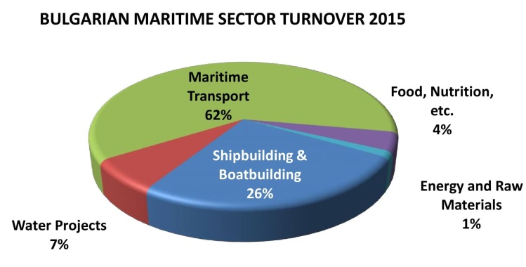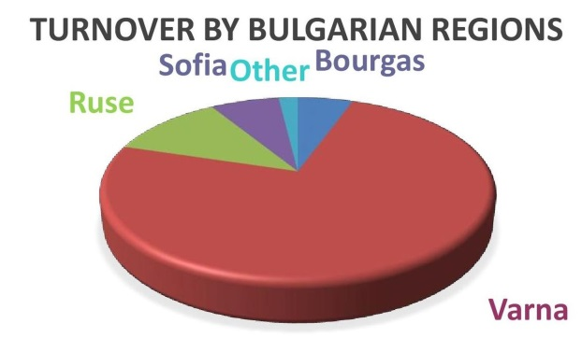
Figure 1. Bulgarian maritime sector turnover 2015 Figure 2. Regions of maritime industry¹

    - Curriculums
The regional meetings considered the curriculums for possible implementation of dual education training. There are two different curricula for the specialty of Naval Architecture and Marine Technology. The old one is applicable for the last year students in academic year 2018/2019. The new one is valid for students who will be 3rd years study.
Taking into account the planed implementation in the project i.e. from October 2018 the suitable target group are the students from 3rd Year in Academic Year 2018/2019. The peculiarities of the curriculum are presented in Table 3

Table 3. Main peculiarities of the curriculum of Naval Architecture and Marine Technology
Semester | No Special/Total subject | Academic hours | Self-study hours | Total hours | ECTS
1 | 2/5 | 195 | 605 | 800 | 30
2 | 3/10 | 330 | 525 | 855 | 30
3 | 2/8 | 285 | 570 | 855 | 31
4 | 2/7 | 300 | 585 | 885 | 32
5 | 5/7 | 255 | 615 | 870 | 31
6 | 6/8 | 315 | 540 | 855 | 30
7 | 6/7 | 330 | 525 | 855 | 31
8 | 4/5 | 240 | 375 | 615 | 22
TOTAL | 30/57 | 2250 | 4340 | 6590 | 237

The study in the Bachelor course finishes with the elaboration of a Diploma thesis or State Exam. Additionally to the presented subjects there are English Language course in semesters 2 to 8.

Situation in CROATIA

Polytechnic Pula, College of Applied Sciences, has been established in 2000 by the Istrian County with support of the local companies. During all this year’s Polytechnic Pula ensures a successful cooperation between enterprises and education, in the way of involving experts from the economy in the teaching process and organizing student professional practice in companies and enterprises. Within professional practice students gain practical knowledge from resolving real industrial problems which contributes to their faster involvement in business production processes.
In December 2015. the Polytechnic Pula and 19 companies from the Istrian County had established The Economic Council of Polytechnic Pula as a consultative body. Nowadays there are 25 members. Aims of the Economic Council are: Development of curricula, Implementation of joint projects, encouraging excellence in students’ research and work, Designing and facilitating student internships and Supporting further development of Polytechnic Pula.
The need for the development of dual education at PTP and support for implementation of dual education has came from the members of the Economic Council of Polytechnic Pula.

- PARTICIPANTS

Participants in ROMANIA
There were participants in the focus group representing different sectors:
- higher education;
- business;
- social partners;
Higher education was represented by:
- University teachers/academic mentors from the Department of Machines and Industrial Equipment, which is coordinating the bachelor’s degree study programme in Mechatronics at LBUS;
- Staff of LBUS (vice-rector, dean of Engineering Faculty, head of the Department of Machines and Industrial Equipment - DMIE), members of DMIE);
- Students at “Mechatronics” study programme.
Business: representatives of partner companies Continental Automotive Systems Sibiu (CASS) and Marquardt Schaltsysteme SCS Sibiu (MSS).
Social partners: representative of the German- Romanian Chamber of Commerce and Industry (AHK RO).

Participants in BULGARIA

    - Technical University of Varna
Participants in the DYNAMIC project from TU-Varna are lecturers from the Naval Architecture and Marine Engineering Department. The work on the project is very well supported by the Vice Rector on Education and Vice Rector on Research. The both of Vice Rectors participated the first regional meeting (Figure 3).
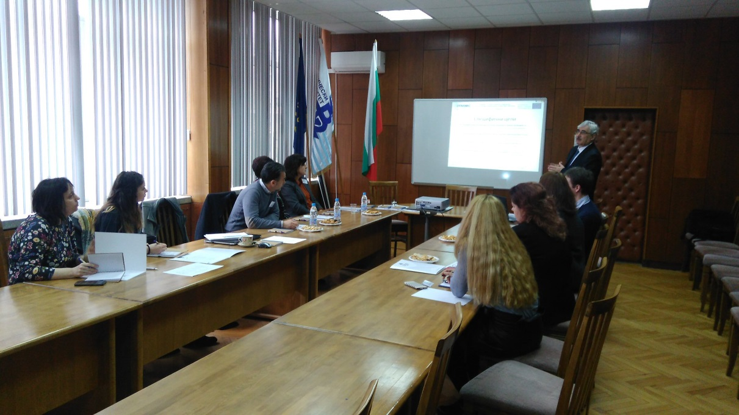
Figure 3. First regional meeting - 21.03.2018

    - Keppel FELS Baltech Ltd (FELS)
The company is established in Varna, July.1994 and it is the 1st European subsidiary of Keppel FELS – Singapore, part of Keppel Offshore & Marine – Singapore. The main activities are basic ship design and detailed engineering and FEM (Finite Element Modelling) of mobile offshore drilling units accommodation platforms, multi-purpose support vessels and offshore supply vessels.
The company has a good collaboration with Technical University - Varna which is expressed in:
- Participation and Leading the Council of business managers at Naval Architecture and Marine Technology specialty;
- Identifying talents from 3rd – 4th year of their engineering study at TU-Varna;
- Tapping and developing talent pool with best graduates from TU-Varna;
- Over 90% of the designers are graduates from the TU-Varna;
- Establishment of TU-Varna Design Lab – KFB Remote Engineering Office, since 01.2012
Involvement of Keppel FELS Baltech Ltd is in the following WP:
- WP2: finalization of the cooperative engineering curricula by stipulating the content of the practical phases for the pilot programs;
- WP3: development of a toolkit to facilitate and support the communication between the key stakeholders involved in the delivery of higher education programs;
- WP4: participate in the training workshops for in-company trainers overall pilot implementation of DET program with ECTS coordination with TUV the pilot implementation.

    - MTG-Dolphin PLC (MTG)
MTG Dolphin is one of leading shipyards in Black Sea/ Mediterranean Sea region. The Shipyard is located at the northern shore of Varna Lake, right in the middle between Varna East and Varna West port, with unrestricted access to the Black Sea. The main facts connected with the big experience in the shipyard are as follows:
- 25 years of experience in repairs of vessels of up to 60’000 tDW.
- More than 10 years of building of highly technological and complex vessels of up to 16’000 tDW.
- More than 700 professionals in the shipyard.
MTG Dolphin is involved in the following WP and tasks:
- WP2: finalization of the cooperative engineering curricula by stipulating the content of the practical phases for the pilot program;
- WP3: in training how to use the toolkit for communication between the key stakeholders involved in the delivery of cooperative higher education program;
- WP4: participation to training workshops for in-company trainers;
- WP5: In the overall pilot implementation of dual engineering practice-integrated study program with ECTS credits in Bulgaria.

    - German-Bulgarian Chamber of Commerce and Industry (AHK BG)
The mission of AHK BG is:
- to foster economic relations between Bulgaria and Germany;
- to create a platform for contacts, partnerships and exchanges between German and Bulgarian companies;
- to consult and support its members in respective business fields;
- new opportunities for successful business;
- to provide a wide range of services; to meet the expectations of its customers.
Involvement of AHK is in WP4 as a leader - responsible (with AHK Romania and CCE) to develop and conduct the trainings for enterprise mentors involved in dual higher education.

- RESULTS FROM THE FOCUS GROUPS

Results from the focus groups in Romania

    - Overview
During the period of February and May 2018 at LBUS have been held three regional focus groups.
- 1st Regional focus group was organized on 26th of February 2018
- 2nd Regional focus group was held on 26th of March.
- 3rd Regional focus group was held on 18th of May 2018.

    - Analysis
Question 1: What is “Mechatronics” ?
The rapid evolution of technology has increased the need for inter- and multidisciplinary engineering specializations within technical universities all over the world, “Mechatronics” being one of the answers for this need.
Consequently, “Mechatronics” can be considered both a field of technical sciences, but also a study programme (specialization) at technical universities all around the world.
Throughout the world, “Mechatronics” as study programme is offered either at bachelor level (6-8 semesters) or at master level (10-12 semesters);
In Romania, studies in “Mechatronics” are offered at bachelor level (8 semesters).
In 2008, at “Lucian Blaga” University of Sibiu, a new bachelor study programme in the field of Mechatronics was started. The Mechatronics specialization has proved successful since the early years of its operation. Every year, the number of candidates willing to pursue this field of study increased significantly. A favouring factor was also the significant industrial development of the automotive industry around Sibiu area, which constantly require many engineers with multidisciplinary training.
The present program aims to offer the existing “Mechatronics” specialization also as dual-study option.

Question 2: What should an engineer in “Mechatronics” be able to do ?
“Mechatronics” could be considered a synergetic combination between Mechanical Engineering, Electronics, Computer Science and Software. However, the engineer in “Mechatronics” should not be expected to replace neither a Mechanical engineer or an Electronics Engineer, nor a Computer Science engineer or a programmer.
A graduate of “Mechatronics” study programme should be seen as a system engineer, an integrator, the person who is able to bridge the gaps between the above-mentioned fields of technical sciences.
An engineer in “Mechatronics” should be able to integrate all the knowledge to design a competitive product and lunch it “just in time” on the market. Moreover, he should be able to assembly and lead a team for that purpose.

Question 3: Can the curriculum of “Mechatronics” be tailored to suit the needs of partner companies ?
At national level, the curriculum design for higher education is regulated by The Romanian Agency for Quality Assurance in Higher Education (ARACIS). Every study programme has to pass two assessment stages: the provisional authorization (when the programme starts) and the accreditation (every five years)
As an example, the curriculum fur “Mechatronics” specialization has to fulfil the following percentages:
Fundamental subjects ≥ 17%
Domain subject ≥ 38%
Specialty subjects ≥ 25%
Complementary subjects ≤ 8%
The lists of fundamental, domain and specialty subjects are also imposed by ARACIS.
Moreover, after two accreditations (each five years), the university is allowed to change the curriculum, without the need of passing a new accreditation only in a percentage of 20%. Such changes can dramatically affect other rules/percentages, so making them is quite a cumbersome process
A better way to tailor the educational process in order to comply with the requirements of the industrial partners is to adapt/change the syllabuses of specialty subjects.
An example of how this approach is working is represented by the syllabus of “Microcontrollers programming” – specialty subject, taught in the 5th semester. It was analyzed by LBUS staff and engineers from the industrial partners. Now the course and practical works are focused upon two main architectures, Microchip PIC16F690 and AVR ATMega328P on Arduino and both assembler and C are taught as main programming languages. After the analysis and the feedback received from partner companies the following changes at the level of curricula were decided: the course will remain focused upon both architectures (Microchip PIC16F690 and AVR ATMega328P on Arduino), the practical works will be focused only on AVR ATMega328P and C will be studied as programming language (only basic assembler knowledge will be taught).
Other specialty subjects targeted by this analysis were Computers programming, Digital Electronics, Power Electronics, Hydraulic and pneumatic driving systems and Programmable Logic Controllers.

Question 4: How will the supplementary hours of practical activities be integrated into the present curriculum ?
At present the “Mechatronics” at LBUS study programme is unfolded on 8 semesters, with a compulsory amount of practical activities of 240 hours. Students do not pursue practical activities in the first study year (1st and 2nd semesters).

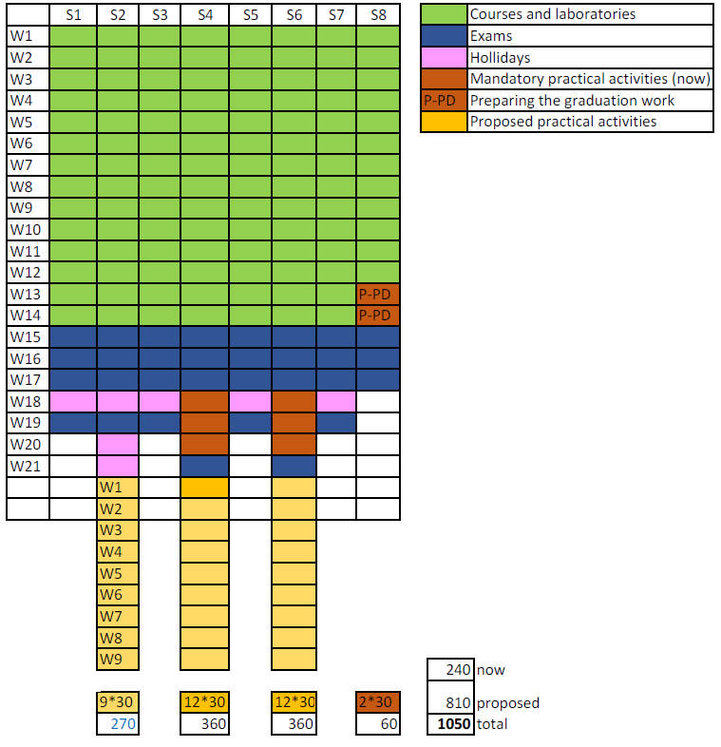
Figure 4. The new proposed structure for practical activities

The integration of the supplementary hours of practical activities into the present curriculum is shown in figure 4. Nine weeks of supplementary hours will be added at the end of the 2nd, 4th and 6th semesters (a period which now is allocated to the summer holidays). Consequently, the total amount of hours for practical activities will reach 1050 for the dual-study specialization.
The partner companies (CASS and MSS) agreed to ensure accommodation for the students pursuing the dual-study specialization. This is needed because usually, the LBUS dormitories are closed during the summer holidays.

Question 5: What should include the syllabus for practical activities ?
A new syllabus for practical activities was designed taking into consideration the following:
- the content was tailored according to the content of the curriculum and the requirements of the partner companies;
- during internships students should become familiar with all sections and activities of the partner companies (CASS and MSS);
- the training items were designed to match the content of “Mechatronics” as multi-disciplinary study programme, the main field of activity of the partner companies, automotive industry the new paradigm of “Industry 4.0”

Question 6: How should the students be selected for the dual-study specialization ?
A selection procedure was proposed and agreed between LBUS and the industrial partners.
The main selection criteria considered:
- academic results (grades) – 30%;
- interview – 70%;
- distance from student’s home to the receiving company location.

Question 7: How should the students be assessed ?
The selection procedure also includes rules for assessment. The assessment will be based upon the following:
- students will elaborate a notebook for practical activities, which should include, among others, the main knowledge achieved during internships;
- the final assessment (at the end of each semester) will be organized as a colloquium, in front of an examination committee;
- the final assessment will consist of discussion upon the student’s activity in the company, the content of the notebook and a Q/A session;
- the student will receive a grade for practical activities.

Results from the focus groups in BULGARIA

    - Main topics discussed during the meetings

The information about the meetings and the participants is given in Table 4.
Table 4. Focus Group Meeting and participants
FG Meeting | Date | Partners | Participants
1-st FGM | 21.03.2018 | TUV; FELS; MTG; AHK BG | 11
2-nd FGM | 18.04.2018 | TUV; FELS; MTG; | 8
3-rd FGM | 16.05.2018 | TUV; FELS; MTG; AHK BG | 10

The main topics during the 1-st FGM (held on 21.03.2018 - Figure 5) were as follows:
- Current peculiarities related to the practical training of students; educational programs for marine specialties and syllabus, etc.;
- Specifics in practical training, programs;
- Possibilities and various ideas and opportunities for setting the foundations of the dual education practices and training;
- Ideas and requirements for partners’ co-operation within the project. How to deal with the challenge to set-up “dual education” in the best way?;
- Identification of more specific issues/problems/tasks for next regional meeting in April at TUV.
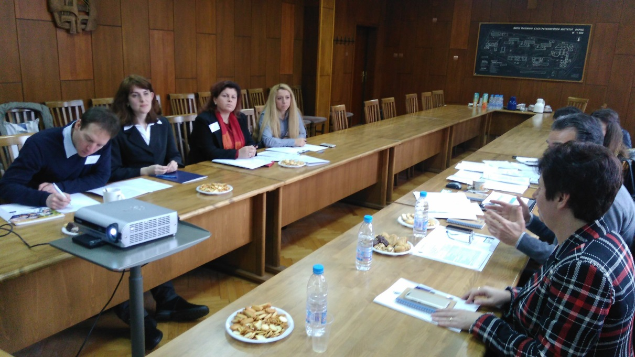
Figure 5. Working moment from 1-st FGM

The 2-nd FGM was held on 18.04.2018 (Figure 6) and the following topics were considered:
- Information about the models for Dual education training (DET) in EU;
- Discussion about the DYNAMIC guidelines for pilot introduction of practice-integrated dual curricula;
- Curricula of NAMT and ME specialties - presentation and discussion of all specific features, in agreement with the corresponding legislation in Bulgaria;
- Ideas and possibilities for implementation of DE, requirements to partners;
- The most efficient schedule for practical education for the students from specialities “NAMT” and “ME” during the summer and winter semester and the summer vacation;
- Schedule for practice-integrated training.
The main topics during 3-rd FGM (16.05.2018 Figure 7) were as follows:
- Specification of the next steps regarding the implementation of dual education training. Personal information for students involved in dual education training and its pilot implementation;
- Scope and presentation for Transnational Meeting in Pula. Outcomes of all 3 national focus group meetings in Bulgaria;
- Discussions of the proposed diary template and contract template;
- Questions and uncertainties to be placed in Pula.

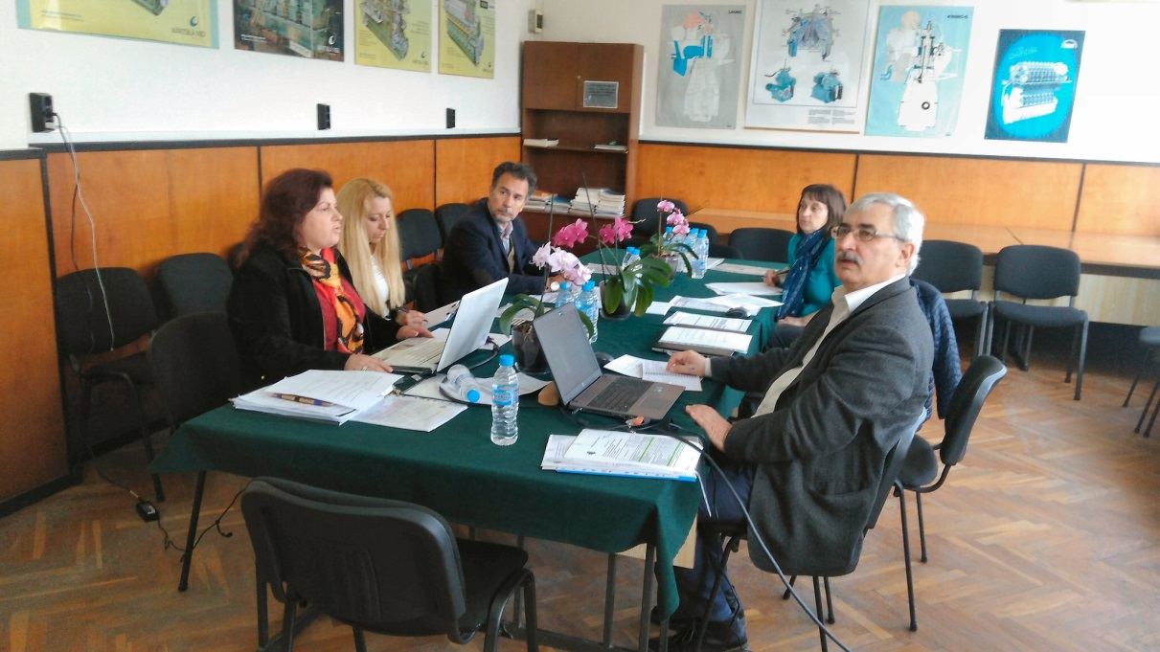
Figure 6. Moment from 2-nd FGM

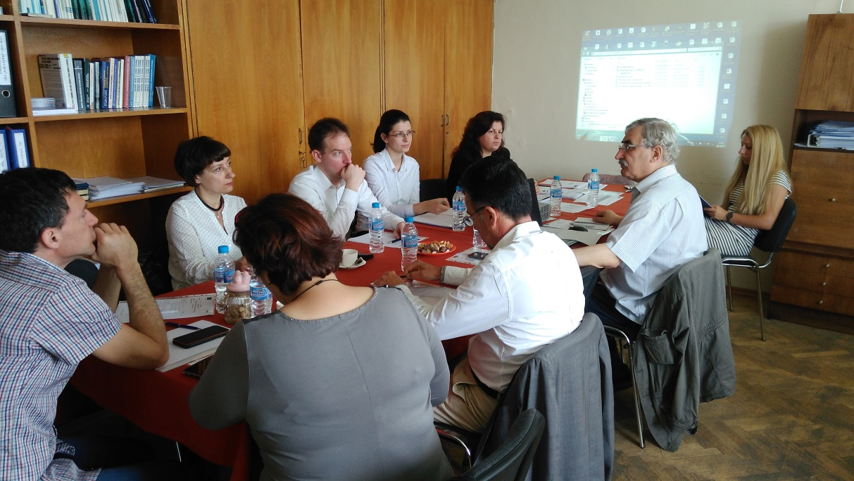
Figure 7. Working moment from 3-rd FGM

    - Main framework for pilot implementation of DET
During the discussions at the 3 meetings, there were outlined the principles of internal (belong to the Technical University Rules) and national legislation that should be taken into account. These rules dictate the choice of the structure of pilot implementation of dual education training. There were also principles mutually agreed with business partners.
The following rules should be taken into account:
- Any adaptation made to the curricula and in the contents of the syllabus, for various subjects, under consideration for dual education, must be approved by the responsible institutions. The procedure starts with a proposal of Department Council, acceptance by the Faculty Council and finally approval by University Council;
- According to the Higher Education Law, the student has to complete his/her training on the curriculum on which he / she started. This means, that in the frame of the project it’s not possible to change the curriculum and to provide a pilot implementation;
- It was agreed that could be useful for the students who are conducting the dual training, the diploma work at last year of study to be related to the activity of the corresponding company. At the same time, there is a rule that a Diploma thesis can develop students with a certain minimum grades. This should be additionally clarified;
- Taking into account the main activities of business partners and the essence of the curriculum of specialty Marine Engineering, the pilot implementation of the dual training is not suitable for the students from this specialty for the entire course of their education. Only some subjects are considered for DET;
- In the enterprises included in the project an appropriate crossing regime has been established. This issue needs to be further organized in the light of the GDPR (General Data Protection Regulation) in force on 25 May. The participants in the project (Technical University of Varna, MTG Dolphin and Keppel FELS Baltech) will act according to accepted own procedure;
- The all documents and corresponding agreements between the Technical University of Varna, Business partner and Student will be agreed between the parties and will take into account all local rules and regulations.

    - Structure of the pilot implementation
There are a number of circumstances that facilitate the organization of dual training in Naval Architecture and Marine Technology specialty:
- The subject “Specialized practice” consists of 60 academic hours (2 ECTS), that are planned to be held during the summer vacation after the 6th semester;
- There are other subjects like “Marine Piping Systems, Electrical Equipment of Ships and Marine Structures, Technical Safety, Structural Mechanics of Ships and Marine Structures, Welding of Marine Structures, Strength and Structure of Ships that include more than 500 self-study hours.
The considered and accepted structure of dual training is organized in two phases: During semesters in TUV and in partner company – in summer vacation after 6th semester.
- Phase in TUV
- Organization of 3 Workshops. These workshops will be held at the Technical University and in each of the two partner companies. The goal of the first Workshop is to promote the conditions among the students. The next Workshops will be in the partner companies where the conditions and requirements of the business partner will be presented;
- Practical tasks during exercises given by the companies. The syllabus on some disciplines to be updated taking into account specific practical tasks posed by businesses.
- Phase during summer vacation
- Special internship after 6th semester to be followed by 3 months practice in the both of companies;
- The practice starts with the student's application and after approval by the company;
- The practice of about 160 hours per month will be paid according to the company conditions;
- The conditions of the practice and the obligations of the parties - student, the company and TUV will be described in the corresponding agreement;
- Special training logbooks will be elaborated for the needs of pilot implementation.

    - Presentation and dissemination of the results
In the period of March to May the work on the DYNAMIC project and some of the obtained results were presented to a wider audience.
After the 1st FGM Mr. M. Erhard from AHL BG gave a lecture (Figure 8) to students of maritime specialties at TUV. He discussed in detail what it means dual education, its importance, positive aspects and outcomes. Students were eager to know more about the dual education systems, there were many questions regarding its provisional organisation and start-up, changes and new moments in curricula and syllabus, evaluation criteria and the enrolment procedures.

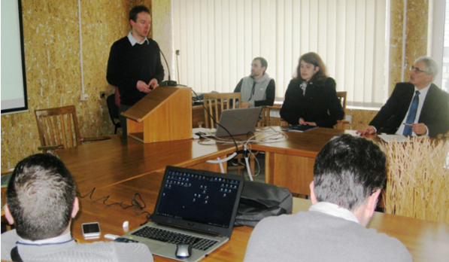
Figure 8. Presentation of. M. Erhard from AHK BG

The main results from the Focus Group Meetings were presented by Petar Georgiev (Figure 9) during the day Conference on 29.05.2018 in hotel “Cherno More” dedicated to European Maritime Day – 20 May and “50 years of first class naval architects and marine engineers graduated of TU-Varna”. The audience of the forum consisted of former and current students and professors in the Naval Architecture and Marine Technology and Marine Engineering specialties (Figure 10)

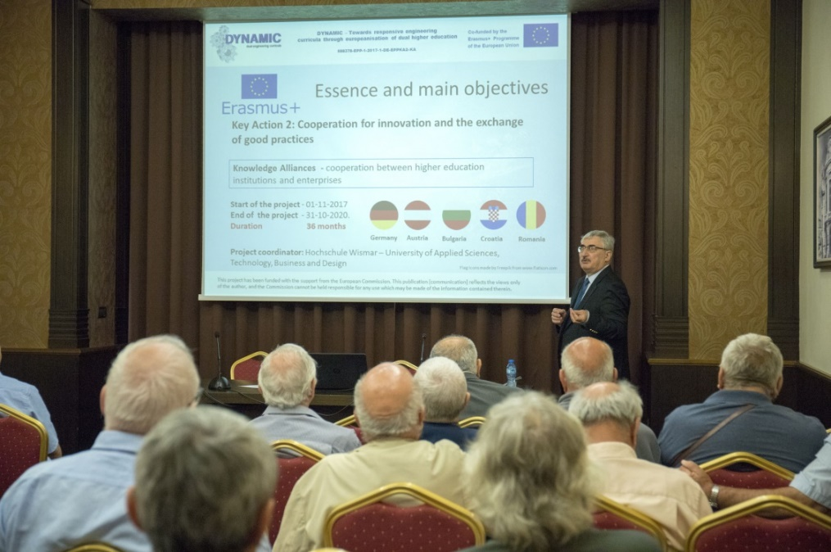
Figure 9. Presentation of Petar Georgiev, from TUV

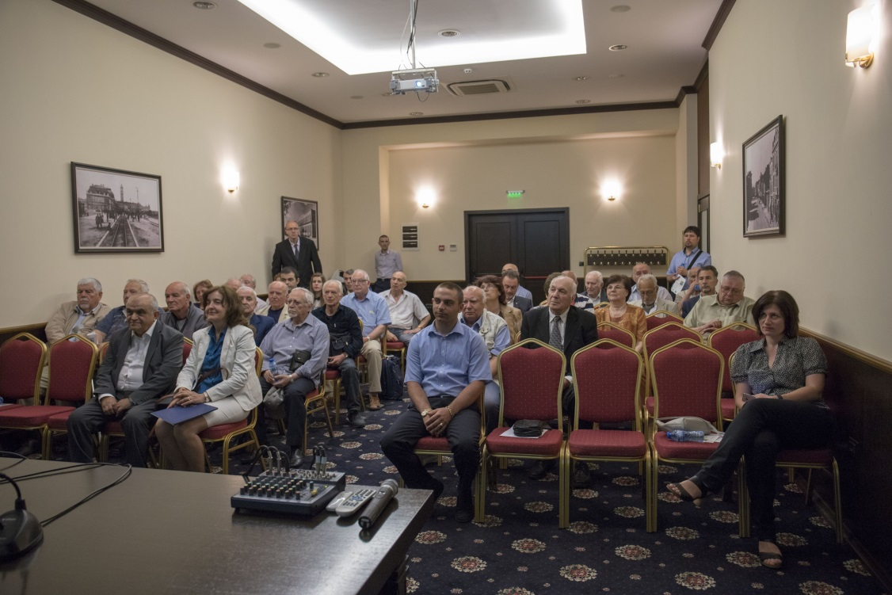
Figure10. Audience of the Day Conference

Results from the focus groups in CROATIA

    - Overview
During the period of February and May 2018 at PTP have been held 4 Regional focus groups.
1st Regional focus group was organized on 26th of February 2018 with topics: Designing a dual educational plan and Organization of teaching process (academic studies) and practical work with two supporting documents (Introduction of Designing a dual educational plan and Calculation of hours per year)
2nd Regional focus group was held on 29th of March 2018 with agenda items: Designing dual study program and definition of mode for student payment in the context of Croatian legal regulations.
3rd Regional focus group was held on 26th of April 2018 with tasks: making a draft syllabus of student practical work teachers in collaboration with industrial mentors, Content of contract proposal between company – student – PTP and introduction of criteria for student selection.
After 3 Regional focus group there was a need to maintain another (4th) Regional focus group for concluding started arrangements on Contract proposal between company-student-PTP in accordance with the Croatian specific and legal requirements, coordination of professors and industrial mentors for finalizing syllabus for courses included in dual study program. This Regional focus group was held on 17th of May 2018.

    - Analysis
During the 4 Regional focus group organized in Croatia there were set 4 topics:

Topic 1: Which are current legal regulations in Croatia
There was described current situation in Croatia for support of dual education, listed responsible institutions, analyzed current legal frameworks. After the analysis it was established that there are NO legal regulations for dual education in Croatia. All partners saw an opportunity and possibility for introducing dual education in current legal framework through:
- The law on Quality Assurance in Science and Higher Education article 20.
- The rules on the content of the permit and the conditions for issuance of a permit for performing higher education activities, the conduct of a study program and the reinstatement of higher education institutions
- Conclusion of the National Council for Higher Education (Class: 003-08 / 11-09 / 0006; no. 355-02-01-11-9) from 16th January 2012
- Conclusion of the National Council for Higher Education (Class: 003-08 / 11-09 / 0006; no. 355-02-01-11-9) from 16th January 2012
  - Changes up to 20% of the content of the study program are made by the Academic Council of HEI`s

Topic 2: Study program adaptation to dual model of education
A few courses from undergraduate study program Polytechnic (duration of 3 years and 180 ECTS) will be offered as a dual course.
Courses involved in dual study program will be from 2nd and 3rd year selected in agreement with industrial partners in accordance with learning outcomes and required competencies.
These courses are: Material Technology I, Teamwork and Practicum III, Electronics II, Material Technology II, Teamwork and Practicum IV, Project Management, Professional Training, Teamwork and Practicum V, Teamwork and Practicum VI and Bachelor Thesis. Total number of ECTS involved in dual education are 43 ECTS.
Professors and industrial mentors will work together on designing dual study program and to develop syllabus for each course involved in dual study program Polytechnic at PTP.

Topic 3: Organization of theoretical and practical phases
Students will participate at a PTP during teaching process and after that they will take a practical part in company.
Students will be at practical phases:
- In 2nd year – total aprox. 8 weeks (February 2019 / June 2019 / September 2019)
  - In 3rd year – total aprox. 10 weeks (February 2020 / June 2020 / September 2020
There will be set equal scoring on all courses and in both companies, which will be written in a book for monitoring the student.

Topic 4: Contractual definition of dual education between PTP – industry - student
Industry partner together with PTP will sign the contract on practical work with student which will list obligations of all parties in implementation of dual education
Industrial partner will sign another contract with student for scholarship. This contract will define amount of monthly payment during the pilot project.

- Conclusions and recommendations

Conclusions and recommendations for ROMANIA

This project aims to implement the dual study option for the existing “Mechatronics” specialization at Lucian Blaga University of Sibiu. At present, the program is unfolded on 4 years (8 semesters), 240 ECTS.
There is no legal framework in Romania yet for implementation of dual education in HEI`s, so by means the DYNAMIC project, a pilot implementation will be done by LBUS and its industrial partners, CASS and MSS.
The adaptation of the curriculum for the dual study specialization will be made by adapting/changing the syllabuses of specialty subjects. The targeted specialty subjects were: Computers programming, Digital Electronics, Power Electronics, Microcontrollers Hydraulic and pneumatic driving systems and Programmable Logic Controllers.
A supplementary amount of 810 hours of practical activities will be added to the existing 240, which will lead to a total amount of 1050 hour for the dual study option.
A new syllabus for the practical activities was designed and agreed between LBUS and industrial partners.
The students in the academic year 2018-2019 will be able to choose between the normal version and the dual version of the “Mechatronics” specialization. A limited number of places are allocated to the dual study specialization, and the selection of the students will be done according to a selection procedure was proposed and agreed between LBUS and the industrial partners.
Also, new rules for assessing the students for the practical activities were established by LBUS and agreed with the industrial partners.
In the adaptation of dual model of education at PTP and Undergraduate study program there will not be made changes in the content of the study program, but only part of teaching process of selected courses will be held in companies from industrial partners.
The implementation of the practical phases for dual study specialization will be formalized by the following contracts/agreements:
- LBUS – industrial partner – student will sign the contract on practical work.
- Industrial partner – student will sign the contract of internship.

Conclusions and recommendations for BULGARIA

According to task 2.2 from WP2 TUV had to organize 3 regional meetings to discuss all aspects related to the pilot implementation of dual practice-integrated training for students from the Naval Architecture and Marine Technology specialty of Technical University of Varna.
In the period from March to May, 3 meetings in TUV were held. The following results were achieved:
- A structure for pilot implementation of dual practice-integrated training in specialty of Naval Architecture and Marine Technology of TUV has been adopted, which takes into account existing national and institutional legislation and existing curricula;
- Pilot implementation of dual learning will be based on a voluntary choice by the students of the 3-year course for the 2018/2019 academic year after approval by the business partners;
- The main part of the training will be provided during summer vacation and will consist of about 160 hours per month paid according to the company conditions;
- All the necessary documentation - contracts, logbooks, reports etc. will be developed taking into account local conditions, based on good practices in partner countries involved in the project;
- At the moment there are not many possibilities to provide practice-integrated dual learning for students of Marine Engineering specialty for the entire course of their education. Their education is more focused on the work of a ship's engineer on board of the ship. However, students in the specialty of “Marine Engineering” in their 4th year of education will be accepted by MTG Dolphin for practical training on “Repair of marine machinery”;
- Students in the specialty of “Marine Engineering” in their 1st and/or 2nd year of education will be considered to undergo for the second part of their practical training on “Metal turning” and/or “Metal fitting” at MTG Dolphin;
- The syllabus for students in the newly accepted specialty - “Design of marine plants and systems” is extremely appropriate for dual education. The possibilities for implementation of dual practice-integrated training for this specialty will be discussed after finishing of the enrolment procedure. It is worthwhile to consider extending the activities after project completion and looking for opportunities in this direction.

Conclusions and recommendations for CROATIA

In the project there will be implement dual study program at PTP in Undergraduate study program Polytechnic, duration is 3 year and has 180 ECTS.
As in Croatia for now, there is NO legal framework for implementation of dual education in HEI`s PTP together with partners from Croatia has saw possibility for realization of pilot project DYNAMIC and implementation of dual education in selected study program, in Conclusion of the National Council for Higher Education (Class: 003-08 / 11-09 / 0006; no. 355-02-01-11-9) from 16th January 2012 that says: „Changes up to 20% of the content of the study program are made by the Academic Council of HEI`s“.
In the adaptation of dual model of education at PTP and Undergraduate study program there will not be made changes in the content of the study program, but only part of teaching process of selected courses will be held in companies from industrial partners.
Surely in Croatia there is the need for legal adoption and regulations of dual education in HEI`s.
Selected courses which will be offered to the students and performed together with industrial partners are:
- From 2nd year: Material Technology I, Teamwork and Practicum III, Electronics II, Material Technology II, Teamwork and Practicum IV,
- From 3rd year: Project Management, Professional Training, Teamwork and Practicum V, Teamwork and Practicum VI and Bachelor Thesis.
Total number of ECTS involved in dual education are 43 ECTS.
During the semester students will participate at a PTP during teaching process and after that they will take a practical part in company:
- In 2nd year – total aprox. 8 weeks (February 2019 / June 2019 / September 2019)
- In 3rd year – total aprox. 10 weeks (February 2020 / June 2020 / September 2020).
PTP – industrial partner – student will sign the contract on practical work.
Industrial partner – student will sign the contract of scholarship.

ACKNOWLEDGEMENT

This Focus Group Report was written by:

from Lucian Blaga University of Sibiu, Engineering Faculty

Sever-Gabriel RACZ
Claudiu Vasile KIFOR
Liviu-Ioan ROȘCA
Radu-Eugen BREAZ
Valentin OLEKSIK
Adrian PASCU
Ilie Octavian POPP
Cristina Maria BIRIȘ
Anca-Lucia CHICEA
Mihai CRENGANIȘ
Claudia Emilia GÎRJOB
Elena SIMA
Melania TERA

from Technical University of Varna, Faculty of Shipbuilding

Petar GEORGIEV
Galina ILIEVA

From Polytechnic Pula, College of Applied Sciences

Tamara ŽUFIĆ KOŠARA

“The European Commission support for the production of this publication does not constitute endorsement of the contents which reflects the views only of the authors, and the Commission cannot be held responsible for any use which may be made of the information contained therein.”

From internal Report of Marine Cluster Bulgaria, 2017

