FOCUS GROUP REPORT
ROMANIA - LBUS

September 2018

I. INTRODUCTION

The present Focus Group Report (FG Report) is based on the results of the regional working groups meetings organized by LBUS, with the partner companies within the framework of the European project titled DYNAMIC – Towards responsive engineering curricula through europeanisation of dual higher education under ERASMUS + Programme, Key Action 2.

The Focus Group Report was written in the context of the project background:

“The project will address the need for more flexible routes for acquiring current industry-related skills necessary to boost and sustain innovation in the sectors identified by the national strategies of Smart Specialisation and regional innovation in the new member states. For this purpose, regular practical phases in enterprises will be integrated in the ongoing engineering curricula to accelerate the update of knowledge traditionally provided by higher education institutions. To achieve that the project will apply a county-adapted model of dual higher education.
The aim of the DYNAMIC project is to develop, implement, test and validate 3 undergraduate programmes in the field of Mechatronics and Robotics (Sibiu, Romania), Shipbuilding and Construction (Varna, Bulgaria) and Mechanical Engineering and Production (Pula, Croatia). In order to ensure successful implementation of the 3 dual programmes, the project will develop a toolkit documentation and assessment of the practical training for academic supervisors. To strengthen the training capacities of the enterprises involved in dual education, the project will develop materials for a presence training of industrial supervisors.
The main intellectual output of the project is “Methodological guidelines for design and implementation of practice-integrated dual higher education programmes in Science & Technology Studies” in the context of Bulgaria, Romania and Croatia. The output will satisfy the need for strategic approach in updating engineering curricula implicating the dual education model. The knowledge and experience gained within the project will be synthesized in this methodological document that will describe the different sets of methods employed at the different stages of the process.
The full commitment of 16 partners from Bulgaria, Romania, Croatia, Germany and Austria and the active involvement of key stakeholders will ensure sustainable long-term exploitation of project results beyond the project life-time.”

2.OBJECTIVES AND METHODOLOGY

2.1. Objectives of the Focus Group Report

The present Focus Group Report (FG Report) aims at:
- analysing the results of regional working groups meetings organized by LBUS with the partner companies;
- review the curricula of the selected programmes;
- defined and analyse the required skills, according to the curriculum of each programme and the requirements of the partner companies;
- define the content and syllabus for the practical works (internships) and map the developed practical phases with ECTS.

2.2. Methodology used

The Report is based on the results of the focus groups.
Focus groups (FG) was organized in Romania (at LBUS), involving representatives of the university involved in the project and the partner companies. Representatives off all participants were involved in the discussions in order to collect the significant data regarding the main objectives of the focus groups. Data were collected by using session data form.

3. SITUATION IN ROMANIA

“Mechatronics” started as study programme at LBUS in the academic year 2008/2009. Since then it became one of the most successful specializations of Engineering Faculty at LBUS. These facts, corroborated with the rapid industrial development of the Sibiu area leaded to the need of organizing “Mechatronics” as dual-study specialization.

4. PARTICIPANTS

There were participants in the focus group representing different sectors:
- higher education;
- business;
- social partners;
Higher education was represented by:
- University teachers/academic mentors from the Department of Machines and Industrial Equipment, which is coordinating the bachelor degree study programme in Mechatronics at LBUS;
- Staff of LBUS (vice-rector, dean of Engineering Faculty, head of the Department of Machines and Industrial Equipment - DMIE), members of DMIE);
- Students at “Mechatronics” study programme.
Business: representatives of partner companies Continental Automotive Systems Sibiu (CASS) and Marquardt Schaltsysteme SCS Sibiu (MSS).
Social partners: representative of the German- Romanian Chamber of Commerce and Industry (AHK RO).

5. RESULTS FROM THE FOCUS GROUPS

5.1. Overview
During the period of February and May 2018 at LBUS have been held three regional focus groups.
1st Regional focus group was organized on 26th of February 2018
2nd Regional focus group was held on 26th of March.
3rd Regional focus group was held on 18th of May 2018.

5.2. Analysis

Question 1: What is “Mechatronics” ?
The rapid evolution of technology has increased the need for inter- and multidisciplinary engineering specializations within technical universities all over the world, “Mechatronics” being one of the answers for this need.
Consequently, “Mechatronics” can be considered both a field of technical sciences, but also a study programme (specialization) at technical universities all around the world.
Throughout the world, “Mechatronics” as study programme is offered either at bachelor level (6-8 semesters) or at master level (10-12 semesters);
In Romania, studies in “Mechatronics” are offered at bachelor level (8 semesters).
In 2008, at “Lucian Blaga” University of Sibiu, a new bachelor study programme in the field of Mechatronics was started. The Mechatronics specialization has proved successful since the early years of its operation. Every year, the number of candidates willing to pursue this field of study increased significantly. A favouring factor was also the significant industrial development of the automotive industry around Sibiu area, which constantly require many engineers with multidisciplinary training.
The present program aims to offer the existing “Mechatronics” specialization also as dual-study option.

Question 2: What should an engineer in “Mechatronics” be able to do ?
“Mechatronics” could be considered a synergetic combination between Mechanical Engineering, Electronics, Computer Science and Software. However, the engineer in “Mechatronics” should not be expected to replace neither a Mechanical engineer or an Electronics Engineer, nor a Computer Science engineer or a programmer.
A graduate of “Mechatronics” study programme should be seen as a system engineer, an integrator, the person who is able to bridge the gaps between the above-mentioned fields of technical sciences.
An engineer in “Mechatronics” should be able to integrate all the knowledge to design a competitive product and lunch it “just in time” on the market. Moreover, he should be able to assembly and lead a team for that purpose.

Question 3: Can the curriculum of “Mechatronics” be tailored to suit the needs of partner companies ?
At national level, the curriculum design for higher education is regulated by The Romanian Agency for Quality Assurance in Higher Education (ARACIS). Every study progamme has to pass two assessment stages: the provisional authorization (when the programme starts) and the accreditation (every five years)
As an example, the curriculum fur “Mechatronics” specialization has to fulfil the following percentages:
Fundamental subjects ≥ 17%
Domain subject ≥ 38%
Specialty subjects ≥ 25%
Complementary subjects ≤ 8%
The lists of fundamental, domain and specialty subjects are also imposed by ARACIS.
Moreover, after two accreditations (each five years), the university is allowed to change the curriculum, without the need of passing a new accreditation only in a percentage of 20%. Such changes can dramatically affect other rules/percentages, so making them is quite a cumbersome process
A better way to tailor the educational process in order to comply with the requirements of the industrial partners is to adapt/change the syllabuses of specialty subjects.
An example of how this approach is working is represented by the syllabus of “Microcontrollers programming” – specialty subject, taught in the 5th semester. It was analyzed by LBUS staff and engineers from the industrial partners. Now the course and practical works are focused upon two main architectures, Microchip PIC16F690 and AVR ATMega328P on Arduino and both assembler and C are taught as main programming languages. After the analysis and the feedback received from partner companies the following changes at the level of curricula were decided: the course will remain focused upon both architectures (Microchip PIC16F690 and AVR ATMega328P on Arduino), the practical works will be focused only on AVR ATMega328P and C will be studied as programming language (only basic assembler knowledge will be taught).
Other specialty subjects targeted by this analysis were Computers programming, Digital Electronics, Power Electronics, Hydraulic and pneumatic driving systems and Programmable Logic Controllers.

Question 4: How will the supplementary hours of practical activities be integrated into the present curriculum ?
At present the “Mechatronics” at LBUS study programme is unfolded on 8 semesters, with a compulsory amount of practical activities of 240 hours. Students do not pursue practical activities in the first study year (1st and 2nd semesters).

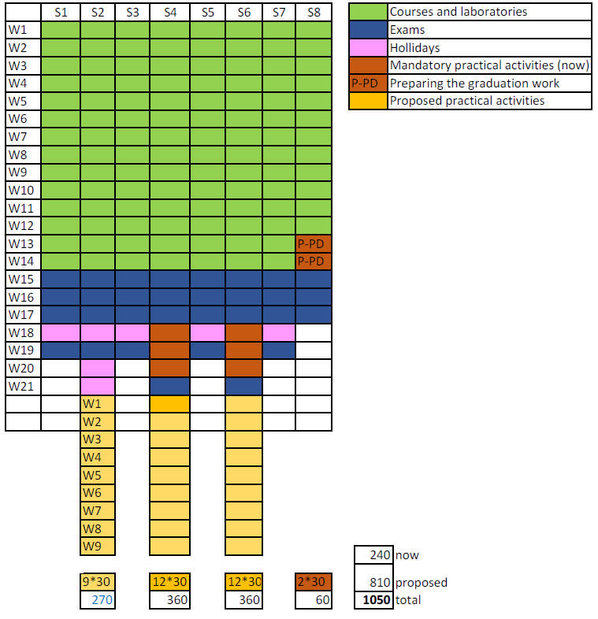
Figure 1: The new proposed structure for practical activities

The integration of the the supplementary hours of practical activities into the present curriculum is shown in figure 1. Nine weeks of supplementary hours will be added at the end of the 2nd, 4th and 6th semesters (a period which now is allocated to the summer holidays). Consequently, the total amount of hours for practical activities will reach 1050 for the dual-study specialization.
The partner companies (CASS and MSS) agreed to ensure accommodation for the students pursuing the dual-study specialization. This is needed because usually, the LBUS dormitories are closed during the summer holidays.

Question 5: What should include the syllabus for practical activities ?
A new syllabus for practical activities was designed taking into consideration the following:
- the content was tailored according to the content of the curriculum and the requirements of the partner companies;
- during internships students should become familiar with all sections and activities of the partner companies (CASS and MSS);
- the training items were designed to match the content of “Mechatronics” as multi-disciplinary study programme, the main field of activity of the partner companies, automotive industry the new paradigm of “Industry 4.0”

Question 6: How should the students be selected for the dual-study specialization ?
A selection procedure was proposed and agreed between LBUS and the industrial partners.
The main selection criteria considered:
- academic results (grades) – 30%;
- interview – 70%;
- distance from student’s home to the receiving company location.

Question 7: How should the students be assessed ?
The selection procedure also includes rules for assessment. The assessment will be based upon the following:
- students will elaborate a notebook for practical activities, which should include, among others, the main knowledge achieved during internships;
- the final assessment (at the end of each semester) will be organized as a colloquium, in front of an examination committee;
- the final assessment will consist of discussion upon the student’s activity in the company, the content of the notebook and a Q/A session;
- the student will receive a grade for practical activities.

6. Conclusions and recommendations

This project aims to implement the dual study option for the existing “Mechatronics” specialization at Lucian Blaga University of Sibiu. At present, the program is unfolded on 4 years (8 semesters), 240 ECTS.
There is no legal framework in Romania yet for implementation of dual education in HEI`s, so by means the DYNAMIC project, a pilot implementation will be done by LBUS and its industrial partners, CASS and MSS.
The adaptation of the curriculum for the dual study specialization will be made by adapting/changing the syllabuses of specialty subjects. The targeted specialty subjects were: Computers programming, Digital Electronics, Power Electronics, Microcontrollers Hydraulic and pneumatic driving systems and Programmable Logic Controllers.
A supplementary amount of 810 hours of practical activities will be added to the existing 240, which will lead to a total amount of 1050 hour for the dual study option.
A new syllabus for the practical activities was designed and agreed between LBUS and industrial partners.
The students in the academic year 2018-2019 will be able to choose between the normal version and the dual version of the “Mechatronics” specialization. A limited number of places are allocated to the dual study specialization, and the selection of the students will be done according to a selection procedure was proposed and agreed between LBUS and the industrial partners.
Also, new rules for assessing the students for the practical activities were established by LBUS and agreed with the industrial partners.
In the adaptation of dual model of education at PTP and Undergraduate study program there will not be made changes in the content of the study program, but only part of teaching process of selected courses will be held in companies from industrial partners.
The implementation of the practical phases for dual study specialization will be formalized by the following contracts/agreements:
- LBUS – industrial partner – student will sign the contract on practical work.
- Industrial partner – student will sign the contract of internship.

ACKNOWLEDGEMENT

This Focus Group Report was written by:

Sever-Gabriel RACZ
Claudiu Vasile KIFOR
Liviu-Ioan ROȘCA
Radu-Eugen BREAZ
Valentin OLEKSIK
Adrian PASCU
Ilie POPP
Cristina BIRIȘ
Anca-Lucia CHICEA
Mihai CRENGANIȘ
Claudia GÎRJOB
Elena SIMA
Melania TERA

from Lucian Blaga University of Sibiu, Engineering Faculty

“The European Commission support for the production of this publication does not constitute endorsement of the contents which reflects the views only of the authors, and the Commission cannot be held responsible for any use which may be made of the information contained therein.”

