D4.1: Inventory of the country-specific and legal requirements
Project information

Grant Agreement Number | 2017 - 2863 / 001 - 001
Project Full Title | Towards responsive engineering curricula through europeanisation of dual higher education
Project Acronym | DYNAMIC
Funding scheme | 588378-EPP-1-2017-1-DE-EPPKA2-KA
Start date of the project | 01-11-2017
Duration | 36 months

Deliverable Information
Deliverable n° | 4.1
Deliverable title | Inventory of the country-specific and legal requirements
WP | WP4
WP Leader | Mr/Mrs Matilda Soare (AHK RO )
Contributing Partners | AHK Bg, AHK ro
Authors | Matilda Soare (AHK RO)  Snia Bankova, Bilyana Genova (AHK BG)  Dr.sc. Rosana Lucijetić (PTP Pula)  Tamara Žufić Košara (PTP Pula)
Contributors | ..............(......)
Reviewers | Ciudin Rodica, Regina Krause (HSW)
Contractual Deadline | dd/mm/yyyy
Delivery date to EC | dd/mm/yyyy

Dissemination Level
PU | Public | ✓
PP | Restricted to other programme participants (incl. Commission Services)
RE | Restricted to a group specified by the consortium (incl. Commission Services)
CO | Confidential, only for the members of the consortium (incl. Commission Services)

Document Log
Version | Date | Description of Change
V1.0 | 18/07/2018 | Document Draft
V.1.1 | 20/07/2018 | First revision
V.1.2 | 25/07/2018 | Second revision
V.2.0 | 29/07/2018 | Final draft
V.3.0 | 31/07/2018 | Final report

Table of Contents

1. Executive Summary 4
2 Introduction 5
3 Country specific and legal requirements in Bulgaria 5
Education structures 5
Status of cooperation 6
Ecomonic and social aspects 6
4 Country specific and legal requirements in Croatia 8
The legal situation in the Croatia 8
Evaluation procedures in higher education: 10
Evaluation procedures in science: 11
The legal regulations of the chamber that work when working with mentors from the industry 11
Training of craftsmen and employers is needed to work with disadvantaged students. 11
Laws or other activities related to vocational education: 12
Laws or other activities related to higher education: 12
5 Country specific and legal requirements in Romania 13
Key features of the education system in Romania 13
University level 16
Dual education 16

- Executive Summary
The present document reports on the country specific and legal requirements for dual education in Bulgaria, Croatia and Romania

The present report provides information about these requirements, the constraints and the possibility of accreditation of dual studies in the countries

The main aim of this report is:
• To give an overview of the legislation in the dual education field
• To inform about the possibilities of dual studies in the countries of the project
• To give an overview about the situation and the need of dual studies in the countries

To achieve these objectives, a research has been done in all the countries and discussions with the parties involved were organised.

2 Introduction

3 Country specific and legal requirements in Bulgaria

Education structures
Institutions for Vocational Education and Training
According to the Vocational Education and Training Act, the main institutions in which VET is implemented are vocational schools, vocational high schools, art schools, sports schools, vocational colleges, vocational training centers, information and vocational guidance centers, etc. Learning through work (VET) is a form of partnership between an institution in the vocational education and training system, with the exception of centers for information and vocational guidance, and one or more employers, which includes:
1. practical training in a real work environment, and
2. training in an institution in the vocational education and training system, with the exception of centers for information and vocational guidance.

Regulatory framework
According to the Constitution of the Republic of Bulgaria, the state creates conditions for organizing and conducting Vocational Education and Training (VET).
The Law on pre-school and school education, which regulates the structure, functions and management of the system of public education, is of paramount importance for the development of the VET system. The law stipulates the conditions and the order for completion of the level of education and for passing to the next degree as well as the characteristics of the general educational minimum and the curriculum.
The Vocational Education and Training Act is crucial for the development of the VET system and for the quality assurance of VET. The law regulates the management of the vocational education and training system on a tripartite basis at national, regional and local level, the organization, the institutions and the funding of the vocational education and training system.
The Higher Education Act regulates the structure, functions, management and financing of higher education in the Republic of Bulgaria.
The Labor Code regulates the social partnership and the collective bargaining as well as the individual employment contracts through which VET activities can receive wide public support and optimal realization in enterprises.
The Employment Promotion Act regulates public relations in vocational guidance and adult education.
The Law on the Recognition of Professional Qualifications was adopted in response to the requirements of the European Union for the complete settlement in Bulgarian legislation of the issue related to the recognition of professional qualifications of the citizens of EU Member States and third-country nationals.
In the spheres VET and Higher Education the Bulgarian government issued the following strategical documents:
- Strategy for the Development of Vocational Education and Training in the Republic of Bulgaria for the Period 2015-2020
- Action Plan for the measures under the Strategy for the Development of Vocational Education and Training in the Republic of Bulgaria for the Period 2015-2020
- Strategy for Development of Higher Education (2014-2020) in the Republic of Bulgaria for the 2014 - 2020 period
- Action Plan for the measures under the Strategy for Development of Higher Education in Republic of Bulgaria for the period of 2014-2020

Status of cooperation
- Project DOMINO "Swiss support for the introduction of dual training principles in Bulgarian education 2015-2019"
- Project “VET” of Advantage Austria in 5 regions of Bulgaria with 6 vocational schools
- Project “APPRENTICESHIP CLUSTER for INDUSTRY-READY ENGINEERS of TOMORROW” with project coordinator Technical University Gabrovo, co-funded by the Erasmus+ Programme of the EU
- Different VET projects of private companies such as Liebherr-Hausgeräte Marica, Kaolin, Kittner Anlagen- und Maschinenbau etc.
- The AHK Bulgaria starts in 2018 a pilot project in the field of VET in cooperation with ABB Bulgaria

Economic and social aspects
- The trend of disproportion between demand and supply of the labor market qualifications is deepening.
- The tendency of discrepancy between the required labor market skills and the quality of the practical and theoretical training of young people in the education system is also persistent.
- Admission of students to vocational education and training does not meet the needs of the economy.
- The vocational training is referred to as a "panacea" to solve the problems in vocational education.
Benefits of Apprenticeship
FOR THE APPRENTICE:
- He / She is in contact with the real world of the company and acquires professional experience.
- He / She experiences working in real conditions.
- He / She checks, in a practical way, if his / her formation in the VET centre corresponds with his / her profile, interests and competences.
- An apprenticeship inside a company increases his / her motivation.
- In some countries, he / she can receive some remuneration and benefits from the social security system.
- Starting to work at an early age in combination with earning money, in some countries, make him / her independent from his parents.
- Apprenticeships facilitate the transition from school to work and increase the employability of the apprentice.

FOR THE HOSTING SME:
- SME meets in person the apprentice and grooms potential future employee who has solid theoretical knowledge. Apprentices contribute to the “freshness” of the company and generate dynamism and innovation. Indeed, a change of generation guarantees the future of business.
- Apprenticeship grooms apprentices according to the SME’s personality and skills needed.
- Apprenticeship enables continuous adaption of the training contents to the needs of a job market in continuous change.
- Apprenticeships offer a return on investment: in many cases, the company recovers the apprenticeship cost.
- Productive work generates necessary products or services for the company.
- Apprenticeship allows strong integration in the company environment (such as company philosophy, colleagues, customers, equipment) and fosters the identification of the apprentice with the company’s values and required skills. Hosting an apprentice promotes the social responsibility of the company. It conveys an image of dynamism, modernity and commitment to society. In this way, the company can gain media coverage and then increase its visibility.
- Apprenticeship can identify and train potential candidates for higher qualified jobs.

FOR THE IN-COMPANY TRAINER:
- Be an in-company trainer is a way to reach higher qualifications for experienced employees.
- Be a company trainer gives you the opportunity to acquire or improve skills such as teamwork, organisation, conflict management and communication.
- The in-company trainer can convey his knowledge and professional skills to the new generations as well as his accumulated practical know-how.
- He / She is constantly updated.
- He / She is in contact with the educational world.
- Being assigned with the task of tutoring apprentices is a sign of trust and recognition by which the company means "We trust you. We value your work. And we want you to pass it on to our future employees."
FOR THE VOCATIONAL SCHOOL:
- They are aware of the company and sector trends and will convey them to the apprentices.
- Teachers can have access to facilities, machineries and innovative technologies held by the company.
- Being linked with companies increases the VET centre educational offer along with its prestige.
- Its support to fulfil the vocational mission of “VET schools” to provide necessary skills and qualifications for the labour market.
- They train motivated, mature and responsible apprentices.

4 Country specific and legal requirements in Croatia

The legal situation in the Croatia
Currently in Croatia an insufficient amount of vocational learning is provided in real work environment in enterprises. According to a 2014 survey of employers (Zaposlimo Hrvatsku), one of the main problem they face is a skills gap, i.e. the skilled labour shortage, especially among young people. Employers indicate that the competencies acquired in the traditional education system are not adequate to the competencies required for successful performance of activities in the workplace. This may be partly the reason of low levels of youth employment in Croatia. This is especially prominent in vocational occupations.
This situation calls for measures to enhance the attractiveness and quality of VET in Croatia. Currently students gain limited practical experience during schooling, mainly through traineeship in schools where the real working conditions are simulated, and only in a small part through traineeship in companies or through apprenticeships in bound crafts. WBL in companies increases employers’ access to workers with relevant skills and knowledge and helps students transition to the world of work. Countries with strong dual vocational education and training systems where learning and practice occur in the company have the lowest youth unemployment rates (OECD 2010). VET programe must respond to society’s structural changes especially high unemployment rates among young people. It is necessary to adapt the education system, so that students can gain quality work experience during education, and not to be additionally trained through expensive measures, which only keep them from the negative statistics.
For work-based learning (WBL) to become a common practice in Croatia the effort has to be twofold. On the one hand it is crucial to engage companies, through familiarizing them with benefits such as avoiding skills mismatch when recruiting new talent, possibility to choose the best talents for future employment and benefits from their productive capacity. On the other, it is necessary to attract young people to vocational training. Unfortunately, the students and parents perception of VET is mostly negative. Vocational occupations are not considered prospective and are usually students’ last choice or are more likely option for students of lower academic achievement. For students, work-based learning experiences provides exposure to professional and organisation setting, helps them to focus their interests and choose suitable career path.
We need a core and tailored approach in designing national policies that strengthen the links between education and training and practices in the workplace, and that are tailored to local needs. Employers demand for talent is an important context for curriculum development and educational reform. EU strategies have recognized the importance of learning in the workplace and lifelong learning in all levels of education, as acquiring, maintaining, and upgrading skills is an essential characteristic for all employees.
A way to establish system of quality is through partnership of all stakeholders that have a role development of VET policy including the ministries, agencies, chambers, schools, enterprises, local communities, parents and employment service. In Croatia there is no thorough statistics/register of apprenticeship as it is divided between ministry and Chamber of Trades and Crafts, counties, etc. Clearer regulations and guidelines have to be created in the implementation of WBL as well as strategy to encourage enterprises to get involved in VET through ensuring incentives for enterprises, establishing better programs for training of in-company mentors that are suitable to their capacities, licensing of mentors, accreditation of companies involved in WBL and creating the register of companies and mentors. In addition, it is important to ensure quality standards in companies involved in WBL and to make sure that apprentices do not compete with employed workers and are not exploited as a cheap labour supply.
Employers are looking for qualified workers, but at the same time they face multiple challenges in an increasingly competitive and unstable economy. A lot of companies have downsized over the past two decades and it is costly and risky to train new employees who have no previous work experience.
Croatian VET programs have not had significant changes over the past two decades, they do not reflect the development of technologies and trends in the profession and are not compatible with the labour market needs. Companies, mostly SMEs, are not actively engaged in providing work-based learning due to the lack of human and financial resources, low appreciation or other reasons. While ongoing educational reform is emphasizing wider implementation of work-based and entrepreneurial learning, there is no unique institution in Croatia which could act as a one-stop point for SMEs interested in apprenticeship. SME’s need assistance in legal, administrative and logistical issues regarding WBL.
We need employers to have more opportunities to collaborate with other VET institutions and participate in shaping vocational programmes that reflect the up-to-date needs of occupations and workplaces as a way to enhance conditions and quality of work-based learning. It is necessary to establish platform for the selection of apprentices among training companies and for the applicants to find apprenticeship posts in SME's, which calls for deeper involvement of chambers in planning and implementation of VET and also making legal and regulatory changes to enable them to enhance their capacities.
Higher education in the Republic of Croatia is performed within university and professional courses. University study programmes qualify students to work in science and higher education, private and public sector and society in general, as well as to develop and apply scientific and professional knowledge. Professional study programmes provide students with an appropriate level of knowledge and skills required to work in applied professions, as well as a direct integration in the working process.
University study programmes have three levels: undergraduate, graduate and postgraduate. Professional study programmes are split into: short professional studies, undergraduate professional studies, and specialist graduate professional studies.
Undergraduate programmes normally last three (180 ECTS) to four (240 ECTS) years. Upon completion, students are awarded an academic title of Bachelor (prvostupnik) with reference to a specialisation. Graduate programmes normally last one (60 ECTS) to two (120 ECTS) years. The total number of credits earned after completing both undergraduate and graduate studies is at least 300 ECTS. Upon completion of both undergraduate and graduate studies, students are awarded an academic title of Master (magistar struke) with reference to a specialisation. Postgraduate university studies are divided into specialist and doctoral studies. Specialist studies last for one to two years. Upon completion, the student is awarded the title of University Specialist with reference to a specialisation (univ. spec.). Doctoral studies last three years (180 ECTS). Upon completion of doctoral study, the academic title of Doctor of Science or Doctor of Arts is awarded (dr. sc. or dr. art.).
Professional studies are divided into short professional studies, undergraduate professional studies, and specialist professional graduate studies. Short professional studies last two (120 ECTS) to two and a half (150 ECTS) years.
Upon completion, students are awarded a professional title of stručni pristupnik/pristupnica with reference to a specialisation. Undergraduate professional studies last three (exceptionally four) years and students earn 180-240 ECTS credits. Upon completion of professional studies students are awarded a professional title of stručni pristupnik/pristupnica with a reference to a specialisation. Specialist professional graduate studies last one to two years and students can earn 60-120 ECTS credits. Upon completion, students are awarded a title of a specialist of the respective profession.The total number of credits earned after completing both undergraduate and graduate professional studies is at least 300 ECTS.
There are currently 1358 accredited study programmes in the Republic of Croatia.
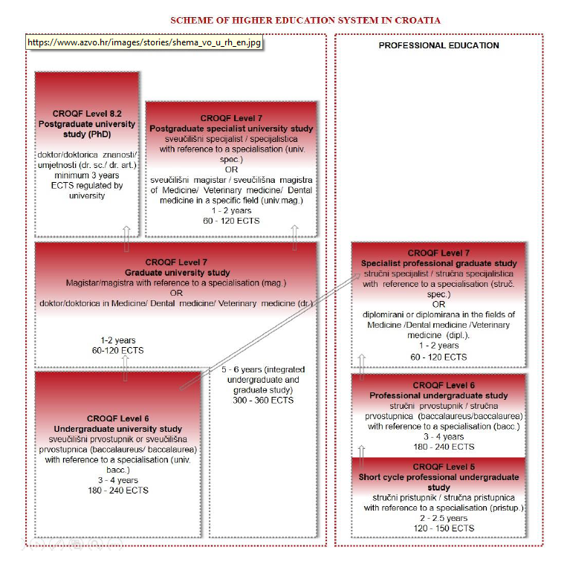

Evaluation procedures in higher education:
- Initial accreditation of study programmes
- Initial accreditation of higher education institutions
- Re-accreditation of higher education institutions
- Theatic evaluation in higher education
- Reaccreditation of part of the activity of higher education institutions
- Feasibility of the public financing of study programmes of public universities
- Evaluation of amendments to approved study programmes
- Audit of higher education institution

Evaluation procedures in science:
- Initial accreditation of scientific organisations
- Re-accreditation of scientific organisations
- Thematic evaluation in science
- Evaluation of research quality for the purpose of establishing centres of excellence in research

The legal regulations of the chamber that work when working with mentors from the industry

There is no co-operation between the chamber and industry mentors in Croatia, and there is no legal regulation for the chambers to act.
Croatia is just about to have a complete analysis and profile of mentors in companies.
In Croatia, according to the Law on Vocational Education (Official Gazette No. 30/2009) and the Crafts Act (Official Gazette 143/2013), practical training and exercises with the employer can not be performed by the person appointed by the employer to the student as a mentor if there is no acquired pedagogic competence or passed an examination that proves the basic knowledge about teaching students. At present, the Program of Acquiring Pedagogical Competences for Vocational Teachers, Teaching Associates and Mentors for 225 Hours and a Load of 60 ECTS credits is in effect. This program does not meet the needs and capabilities of most companies in the Republic of Croatia (90% are small and medium-sized enterprises). It is necessary to adopt legal frameworks regulating company-employer obligations in relation to organization and implementation of professional practice and to provide certain benefits for companies employers who practice.
• There is insufficient number of trades and companies to admit students to professional practice. Specifically, mentors from companies do not know how to evaluate students' knowledge and skills. Some mentors give good grades even though the student does not show the acquired knowledge and skills. Mentors "liar" the presence of students in practice.
• There is no communication between companies working with the same students. When a student changes a business because his behavior is "chasing", there is no communication between a former and a future mentor in a company - students are still acting irresponsibly.
• Some schools because of the specificity of educational programs and conditions can organize school practice in a real work environment, within school teaching. The financial and real estate situation is not similar to other forms of enterprise-based learning.

Training of craftsmen and employers is needed to work with disadvantaged students.
• The aforementioned assistance should be real and not declarative.
• Possibility of a Chamber for Additional Education of Students if School or Enterprise
Do Not Have Opportunities (Space, Tools, etc. ), and within the curriculum -
chambers should have training centers (as in Germany). The Chamber should carry out
exams with independent assessment of the acquired knowledge and skills.
• The Chamber must assume much of the competence over vocational education not
only through non-financial but also financial assistance and the provision of
competence centers such as Germany
• Provisions should be made to release entrepreneurs from certain schemes if they are to
receive apprentices.
• Qualitative evaluation of the impact of mentors who are in charge of non-classroom
professional practice
Scholarships for missing professions are needed.

LAWS OR OTHER ACTIVITIES RELATED TO VOCATIONAL EDUCATION:
Law on Vocational Education ("Official Gazette", 30/2009)
Craft Law (Official Gazette 143/2013)
Ordinance on the manner of organizing and conducting classes in vocational schools (Official Gazette, No. 140/2009)
Ordinance on Procedure and Method for Applying Examination Exam (Official Gazette, No. 63/2014)
Ordinance on procedure and method of issuing licenses (licenses) for performing practical training and apprenticeships (Official Gazette 37/2015).
Ordinance on Minimum Conditions for Learning Contracts (Official Gazette 63/2014)
Decision on the adoption of a program for acquiring pedagogic competences for vocational teachers, teaching assistants and mentors (Official Gazette No. 8/2016)
Rulebook on conditions and ways of continuing education for a higher level of qualification (Official Gazette No. 08/2016)
Labor Law (Official Gazette, 93/2014)
Ordinance on jobs that can not be used by a minor (Official Gazette 89/2015)
Rulebook on jobs where juveniles can work and activities to be attended (Official Gazette 62/2010)
Vocational Education and Training System Development Program for the period from 2016 to 2020

LAWS OR OTHER ACTIVITIES RELATED TO HIGHER EDUCATION:
Law on Quality Assurance in Science and Higher Education (Official Gazette, No. 45/09)
Law on Scientific Activities and Higher Education (Official Gazette 123/03, 198/03, 105/04, 174/04, 46/07)
Law on Recognition of Foreign Educational Qualifications (Official Gazette 158/03, 198/03, 138/06)
Law on ratification of conventions on recognition of higher education qualifications in Europe (Official Gazette 9/02, 15/02)
Act on Academic and Professional Names and Academic Degrees (Official Gazette 107/07)
Ordinance on the conditions for selection in scientific sound (Official Gazette 84/05, 138/06, 42/07, USRH Decision 120/07)
Rulebook on Conditions and Procedure for Issuing Licenses for Performing Scientific Activities ("Official Gazette", No. 97/07)
Rulebook on Evaluation of Scientific Organizations (Official Gazette, No. 39/05, 104/08)
Ordinance on Scientific and Artistic Areas, Fields and Branches (Official Gazette 118/09)
Ordinance on the organization and manner of work of regional councils and parent committees (Official Gazette, No. 76/05, 113/05, USRH Decision, 118/05, 55/09)

5 Country specific and legal requirements in Romania

Key features of the education system in Romania

Romania’s education system is centralised, both horizontally and vertically. All key responsibilities for education strategy, policy and delivery are concentrated within the Ministry of National Education and Scientific Research (MNESR). Several specialised bodies provide input to the ministry, but there is no fully independent evaluation body.
Locally elected authorities play very little role in the design and delivery of education policies. The MNESR directly steers and monitors the implementation of national policies at the local level through the County School Inspectorates (CSIs).
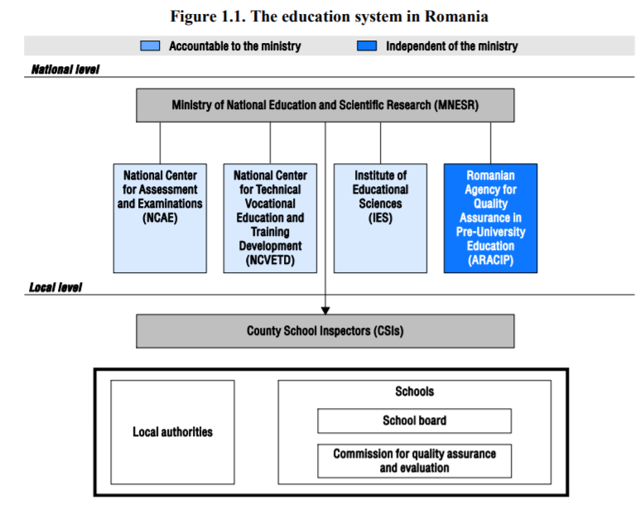

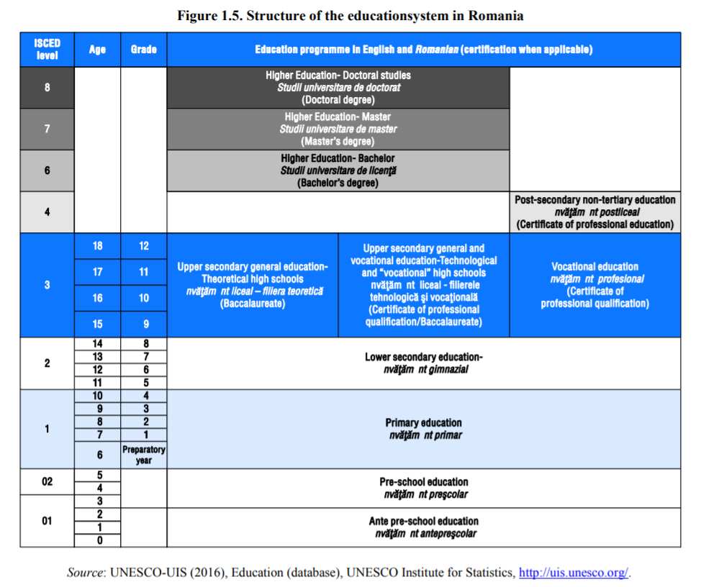
Education in Romania is compulsory for 11 years, from the Preparatory Grade in primary school to Grade 10 of upper secondary education. Most students in these grades attend public schools, with only approximately 1% enrolled in private institutions.
Student selection into different education programmes starts early in Romania, at the age of 14. At the end of lower secondary education (Grade 8), Romanian students take a national examination, which assesses their performance in mathematics and Romanian language and literature. Results in this exam, their average grade at the end of each year of lower secondary and students’ individual school choices determine the upper secondary school and the type of programme students will attend.
Students may be assigned to one of three types of high school: technological, theoretical and “vocational” (Figure 1.5). Technological high schools combine academic and vocational programmes. The theoretical and vocational high schools both follow an academic programme, but the latter have a special focus on arts, sports, theology or the military.
At the end of upper secondary education, students from all three types of high school must pass the baccalaureate examination if they wish to access tertiary education.

University level

In the wake of the Bologna Agreement most Bachelor’s programs take 3 years to complete. However, some programs take longer to complete, for example those in some technical fields, medicine, and architecture.
Master’s programs take 2 years beyond the Bachelor’s degree. Master’s programs are a prerequisite for admission to PhD programs.
PhD programs usually take 3 years to complete. Under special circumstances, the duration of study may be extended by 1 or 2 years.
According to a Ministry of Education report of 2007 (http://www.edu.ro/index.php/resurse/7942), in Romania higher education is provided by universities (universități), institutes (institute), study academies (academii de studii), schools of higher education, and other similar establishments, collectively referred to as higher education institutions (HEIs) or universities. HEIs can be state-owned or private; they are non-profit, apolitical in nature and focused on the public interest. (http://www.fulbright.ro/media/pdf/Monograph%20on%20Higher%20Education%20in%20Romania.pdf)
Starting with the summer of 2011 and the implementation of the new Education Act, universities were divided into three tiers (http://chestionar.uefiscdi.ro/) (info in Romanian):
• Universities focusing on education (which offer only Bachelor degrees);
• Universities focusing on education and scientific research and universities focusing on education and art (offering Bachelor’s and Master’s programs);
• Universities with an advanced research and education focus (which offer Bachelor’s, Master’s, as well as PhD degrees.

Dual education
The dual education in Romania is officially stated at EQF 3 level in professional schools (scoala profesionala in sistem dual). The pupils can choose after the eighth grade to learn an occupation in this type of schools.
The dual education at EQF 3 level takes 3 years, with a theoretical part in the school and a practical part in the company.
At the end of this period the graduates get a professional certificate. They can take a job in a company or they can study two more years to finish the high school and get their baccalaureate, which allows them to study at a university.
The dual education is regulated in Romania by the Ministry of Education through the Nationl Center for vocational education (Centrul National pentru Dezvoltarea Invatamantului Profesional si Tehnic).
The legal framework is regulated through different emergency decrees added to the National Education Law.

There is another type of in-company learning in Romania, which is called apprenticeship (ucenicie). The participants learn only at work, they are not obliged to follow theoretical courses. At the end of the apprenticeship they get a certificate. This form of training is regulated by the Labour Ministry.

There are no dual studies at university level. In the university curricula it can be introduced a minimum of 2-3 weeks of practical phases during the university year, beginning with the second year.
For the practical phases the university have to establish a learning and practical plan for the students.
The companies to accept students have to be active in the field of studies of the faculty and to have sufficient expertise, equipment and knowledge.
The companies should also provide mentors for the students and after the practical phases they have to write an evaluation for them.
There is no legislative indication that the mentors should have a pedagogical background or studies.
Usually in Romania there are a lot of students working during their studies, so they already have practical experience in the companies.

In order to be able to introduce more practical phases in the curricula of one specialisation in the faculty, there are some legal aspects we should take into consideration.
-the study programmes in Romania are accredited by ARACIS (the national agency for accreditation of university studies)
-the study programmes are reaccredited every five years, in the meantime a change of 20% of the curriculum can be undertaken
-the study programmes should include from a list published by ARACIS a certain number of general fundamental courses, domain courses, special field courses and complementary courses
-one ECTS is 25 hours
-the study programmes should have 26– 28 ore didactical activities per day

There are some constraints to introduce a real dual study programme at university level in Romania, but with a pilot project, where the practical phases could be introduced during the vacation period, we can deliver an example for the authorities, in order to undertake some regulations in this respect.

6. Conclusion
In all countries involved in the project (Bulgaria, Croatia and Romania) there is a huge need of professionals, who have the skills needed in the changing world of business. All the countries point out the problem that the graduates from the university do know the theoretical part of their qualification, but they are not well prepared for the practical part. They do not have the skills needed in the business environment like critical thinking, decision making, team work or emotional intelligence.
The students, who are working during their studies have the problem that they cannot always attend the theoretical courses and develop a lack in the basic knowledge needed in their field.
Also, during the working hours, they are undertaking sometimes no specific tasks regarding their qualification and they are not supervised by a mentor. So, the learning process during the work is not complete.
As mentioned before the mentors are not obliged to have a didactical qualification, in order to be able to take care of the students. But as we see from other dual systems (Germany, Austria) it is recommended for the tutors to have didactical skills, to be able to give appropriate feedback or to evaluate the student.
That is why a well-structured dual study programme would be the best solution for the students who are willing to develop both parts, the theoretical and the practical one. Ans also a solution for the companies in search of professionals.

